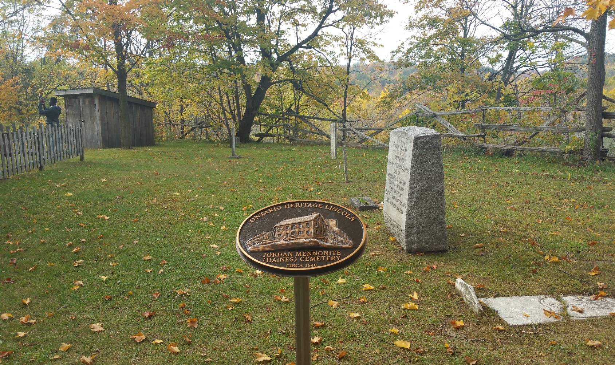

|  |  |
| --- | --- |
|  | Ground Penetrating Radar Survey  of the Jordan Historical Museum Site |
|  |  |
|  | Internment Exploration Study - Thesis Final Report  May 27, 2016 |

 

May 27, 2016

Project ID: 201516-14

Helen Booth (Museum Director)

Jordan Historical Museum

3800 Main Street

Lincoln, Ontario, Canada

L0R 1S0

Dear Ms. Booth,

**RE: Jordan Historical Museum Site, owned by the Town of Lincoln – Ground Penetrating Radar Survey**

Please accept this letter of formal deliverance for the Jordan Historical Museum Site, owned by the Town of Lincoln – Ground Penetrating Radar Survey Project Final Report.

The objective of this thesis project was to perform a Ground Penetrating Radar (GPR) survey of the lands owned by the Jordan Historical Museum to search for all possible interments and to record subsequent findings. The attached report consists of the final project results. As of **May 27, 2016**, the project is 100% completed, with approximately 903.5 hours expended. The project had a total cost of **$90,228.24**. The cost assumes coverage of labour, rentals and incidentals required for completion of the project. An Electrical Resistance survey was added to the project scope, in turn increasing the required working hours and cost to complete the project goal. After receiving training for the equipment at Western University, the team completed the survey of the site on May 7, 2016. The data were then processed at Western University. Further analysis, map making, and recording of findings were finalized at Niagara College. A presentation of subsequent findings in the form of a formal report and a presentation is scheduled for **June 1st, 2016**. Despite initial difficulties with the equipment the GPR and Electrical Resistance survey were able to detect possible, interments on the west side of the Fry House.

Should you have any questions or concerns regarding the attached assignment, or if there are any technical issues regarding the document, please feel free to contact me at 647-388-3360 or via email at jess.chan89@gmail.com. We look forward to receiving your comments and advice. Thank you for your time and attention.

Kindest Regards,

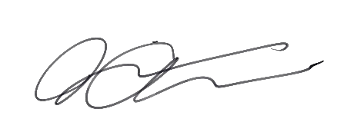

**Jessica Chan, B.A.**

Project Manager/GIS-GM Certificate Candidate

JC/ TV, JJB

|  |  |  |  |
| --- | --- | --- | --- |
| CC: | Jonathan Jn Baptiste  (GIS Analyst) | Travis Vanos  (GIS Analyst) | Ian Smith  (Project Advisor) |

**Enclosure:** Jordan Historical Museum – Ground Penetrating Radar Survey Thesis Report

# Executive Summary

The Jordan Historical Museum currently occupies a parcel of land that once served as a location for a church, a small school, and the historical Fry House, which was built by Jacob Fry in 1815. As historical records indicate, a cemetery has been associated with a former church on the property. While some graves have clear indicators, by means of headstones, the full extent of the cemetery grounds is not known and if any other burials may exist on these grounds. The Jordan Historical Museum, in conjunction with the Town of Lincoln and the Jordan Historical Museum of the Twenty Volunteer Association have retained JJT Consulting to conduct Ground Penetrating Radar (GPR), Electrical Resistance, and Total Station surveys of the Jordan Historical Museum Site to report on the locations of possible interments, and document these possible locations in formal map documents.

This report, serves as the final report on the findings and analysis of the GPR and electrical resistance surveys of the Jordan Historical Museum Site. A presentation of the findings and results, open to the public, will be presented to the Town of Lincoln on June 1st. On June 8th, the presentation will be presented again at the Glendale Campus of Niagara College for public viewing.

The total cost of this project was approximately **$90,229.24.** The budget presented in this report is for ***learning purposes only***; the client is in no way expected to incur these costs. As of May 27, 2016, the project is 100% completed, with approximately 903.5 hours expended. While the initial project budget was estimated to be $46,674.32, JJT expanded upon the original proposal to include an Electrical Resistance survey to supplement the findings of the GPR survey. Sustainable Archaeology and Western University also supplied the Resistivity Meter. While this extra work greatly impacted the original budget estimate in terms of labour commitment, it did not impact the proposed schedule. As a result, the data and the understanding of the possible interments at the study site was greatly increased with this expansion in project scope.

After completion of the survey grounds on May 7th, 2016, the results of the GPR survey were processed at the Western University. These data were analysed and mapped to give a clear understanding of potential interment locations on the Jordan Historical Museum Site. After completing the maps, collected data were reviewed and compiled into a report that was submitted to the client for approval. Several areas of interest were found with the GPR. These findings could not always be seen through an electrical resistance survey as the soil content was not altered, and only the GPR wave reflections are highly visible. Evidence exists for a burial area on the premises along the west-side of the Fry house.

The report also includes an explanation of the methodology executed, discussion of results and recommendations for future surveys.

# Acknowledgments

The Jordan Historical Museum Ground Penetrating Radar Survey of the Jordan Historical Museum Site project would not have been successful without the support of:

* **Helen Booth (Museum & Culture Administrator), Jordan Historical Museum, Sport, Recreation and Culture Department, Town of Lincoln, Jordan Historical Museum of the Twenty Volunteer Association, Ray Konkle (Volunteer Association Vice-President), and Assad Hoosein (Director) Sport, Recreation & Culture at the Town of Lincoln**
* Thank you for this amazing opportunity to perform this study on the grounds of the Jordan Historical Museum Site. Thank you for your financial support, making this project possible.
* **Ian Smith (Advisor)**
* Thank you for all your guidance, support, and the amount of time you spent with us. You have taught us so much that cannot be learned in a classroom.
* **Edward Eastaugh, Sustainable Archaeology, and Western University**
* Thank you for your endless support and training throughout our surveying period. We could not have done this without your excellent teaching.
* **Janet Finlay (Thesis Coordinator)**
* Thank you for matching us to this phenomenal project, the experience and knowledge we received cannot be measured.
* **Alan Unwin (Associate Dean Environmental and Horticultural Studies), Shannon Collison (Administrative Assistant of the School of Environmental and Horticultural Studies), and Niagara College**
* Thank you for all of the support including the provision of the surveying equipment and the incredible opportunity to partake in this thesis project.
* **Niagara College GIS-GM Classmate Volunteers**
* Thank you to all our fellow classmates who helped us with our GPR data collection - Paresh Parikh, Oreva Oputeh, Alice Lin, Kelly To, Felicitas Hockton, Matt Mort, Brent Matthew, Shannon Millar, and especially Mark Wilkinson who helped us over many days.

# Stakeholders

Client - Helen Booth (Museum & Culture Administrator), Jordan Historical Museum, Sport, Recreation and Culture Department, Town of Lincoln, and Assad Hoosein (Director) Sport, Recreation & Culture at the Town of Lincoln

JJT Consulting - Jessica Chan (Project Manager)

Jonathan Jn. Baptiste (GIS Analyst)

Travis Vanos (GIS Analyst)

Ian Smith (Project Advisor)

Janet Finlay - Niagara College Geographic Information Systems - Geospatial Management Thesis Coordinator

Jordan Historical Museum - Helen Booth, Museum and Culture Administrator

Jordan Historical Museum of the Twenty Volunteer Association

Edward Eastaugh - Sustainable Archaeology, Western University

Niagara College

Table of Contents

Executive Summary i

Acknowledgments ii

Stakeholders iii

1.0 Introduction 1

1.1 Challenge/Problem Statement 1

1.2 Study Area Delineation 1

1.3 Project Goal & Objectives 4

1.3.1 Using GPR to detect interments 4

1.3.2 Mapping potential interment locations with GIS 4

1.3.3 Using a Resistivity Meter to aid with the GPR survey 4

2.0 Background 4

2.1 Museum History 4

2.2 Literature Review 6

2.3 Sustainable Archaeology 7

3.0 Geophysical Exploration Methodology 7

3.1 Grid Preparation 8

3.2 Ground Penetrating Radar 8

3.3 Resistivity Meter 11

3.4 Geo-referencing and Ground Truthing 13

3.6 Data Analysis and Required Resources 15

3.6 Resistivity Meter Data Analysis 16

4.0 Results and Analysis 18

4.1 Post Survey Data Processing 18

4.2 Discussion and Summary of Results and Findings 24

5.0 Project Management 41

5.1 Schedule 41

5.2 Final Cost Update for GPR Survey of Museum of Jordan Interments 44

5.3 Budget 44

5.4 Earned Value Management (EVM) 45

6.0 Challenge Management 47

6.1 Equipment 47

6.2 Software Availability 48

6.3 Interment Location and Obstructions 48

6.4 Soil Composition 49

7.0 Closure and Discussion 50

8.0 Recommendations 50

Bibliography .

Appendix 1 .

Project Terms of Reference .

Project Overview Statement .

Appendix 2 .

Public Media .

Glossary .

List of Figures

Figure 1 - Map of the Study Area 2

Figure 2 - Jordan Historical Museum Resistivity Meter Survey Area 3

Figure 3 - The Fry House in its Current Location (Source: Jonathan Jn. Baptiste) 5

Figure 4 - Large Black Walnut Tree on East Side of Premises (source: Travis Vanos, May 2016) 8

Figure 5 - Jessica Chan of JJT Consulting using GSSI’s SIR-3000 Cart System (source: J Jn. Baptiste, May 2016) 8

Figure 6 - Traverse Direction of Ground Penetrating RADAR Survey 9

Figure 7 - Typical 10 m by 10 m Grid with 25cm Transects (Source: Travis Vanos, 2016 10

Figure 8 - Total Station Locations in Relation to the Resistivity Meter Grids 12

Figure 9 - Known tombstones on the study grounds (Source: Travis Vanos, 2016) 13

Figure 10 - Surface Tombstones vs. Known Coordinates 14

Figure 11 - GPR readings as seen in RADAN 6.0 15

Figure 12 - Disturbed soil at approximately 1m 16

Figure 13 - Mosaicked resistivity meter results 17

Figure 14 - GPR Survey Results at Approximately 10 Nanoseconds 19

Figure 15 - GPR Survey Results at Approximately 20 Nanoseconds 20

Figure 16 - GPR Survey Results at Approximately 30 Nanoseconds 21

Figure 17 - GPR Survey Results at Approximately 40 Nanoseconds 22

Figure 18 - Resistivity Meter Results 23

Figure 19 - Comparison of GPR and Resistivity Meter results of the area immediately east of the Fry House 25

Figure 20 - Possible Burial Locations within the Historical Museum of Jordan Grounds - West side 26

Figure 21 - Tombstone set into the cliff side (Source: Jonathan Jn Baptiste, 2016) 27

Figure 22 - Location of the tombstone on the cliff side 28

Figure 23 - Possible interment beside Dr. Bowman marker 30

Figure 24 - Possible interments east of the Fry House 32

Figure 25 - Area of interest north of the Fry House, east of the cobblestone path 34

Figure 26 - Possible Foundation of old Mennonite Church 36

Figure 27 - Possible old path and foundations by the schoolhouse 38

Figure 28 - Potential Interment Locations and Proposed Site Redevelopment 40

Figure 29 - Work Breakdown Structure of Project 43

Figure 30 - Earned Value Management Chart 46

Figure 31 - On the left -"Striped" results of Grid 2 from the original tow cart; on the right – results of Grid 2 using the push cart 47

Figure 32 - Tow Cart (on the right) and Push Cart (on the left) (Image source: Ian Smith, 2016) 48

Figure 33 - Map of the Soil Composition in the Area 49

List of Tables

Table 1 - Approximate nanosecond to depth penetration comparison 18

Table 2 - Schedule of Major Milestones 41

Table 3 - Project Phase Completion Dates and Approval Dates 42

Table 4 - Major Project Tasks 42

Table 5 - Total Cost of Proposed GPR Survey 44

Table 6 - Total Cost of the Project 44

# 1.0 Introduction

The Jordan Historical Museum, located in the Town of Lincoln, was established in 1953 and currently occupies a plot of land that once served as a location for a church (Booth, 2013). The grounds house several structures including an administrative building, small school and the “Fry House”, which is a European style Mennonite home built by Jacob Fry in 1815.

The project investigated by means of Ground Penetrating Radar (GPR) and Electrical Resistance survey, whether there were any potential unmarked interments and mapped their location locations using Geographic Information Systems (GIS).

## 1.1 Challenge/Problem Statement

The Jordan Historical Museum Site has the intention of redeveloping the Jordan Historical Museum Site with the addition of a building expansion/addition known as the Lincoln Heritage Gateway. There has always been some level of uncertainty regarding the extent of the burials at the site. No known burial records for the Mennonite church, now occupied by the Fry House exist. That lack of knowledge raised concerns over the possibility of burials extending beyond what is thought to be the boundaries of the Mennonite cemetery.

Mr. Ray Konkle (former mayor of the Town of Lincoln and current Vice-President of the Twenty Volunteer Association) approached Mr. Ian Smith (project advisor) and Ms. Helen Booth (Museum & Culture Administrator) with the proposal of using GPR to survey the Jordan Historical Museum Site. The project opportunity was set up in the summer of 2015. The Project Terms of Reference used to set up the team with the project was assembled by Niagara College, the Town of Lincoln, and the Museum Staff.

## 1.2 Study Area Delineation

The survey area consisted of the site around an administrative building, the “Fry House”, which was moved to its present location atop the former church building, as well as a pre-existing Mennonite cemetery. The entirety of the Jordan Historical Museum Site can be seen in Figure 1. Although known tombstones and grave markers are present on the cemetery grounds, the Town of Lincoln, Jordan Historical Museum and Heritage Committee members sought to conduct a survey of the premises to identify potentially unmarked burial/interment locations. The Ground Penetrating Radar (GPR) survey was conducted within the area of interest, as seen in Figure 2 below showing the area of interest for this project. Additionally, an Electrical Resistance survey was added to cover the site with a high potential for interment locations, as seen in Figure 3.

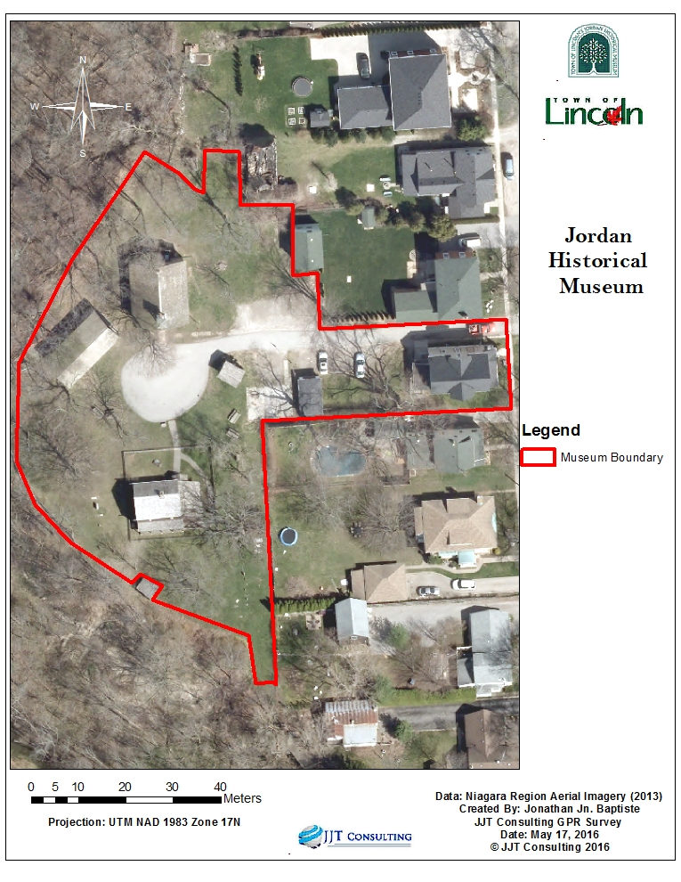

Figure 1 - Jordan Historical Museum Site

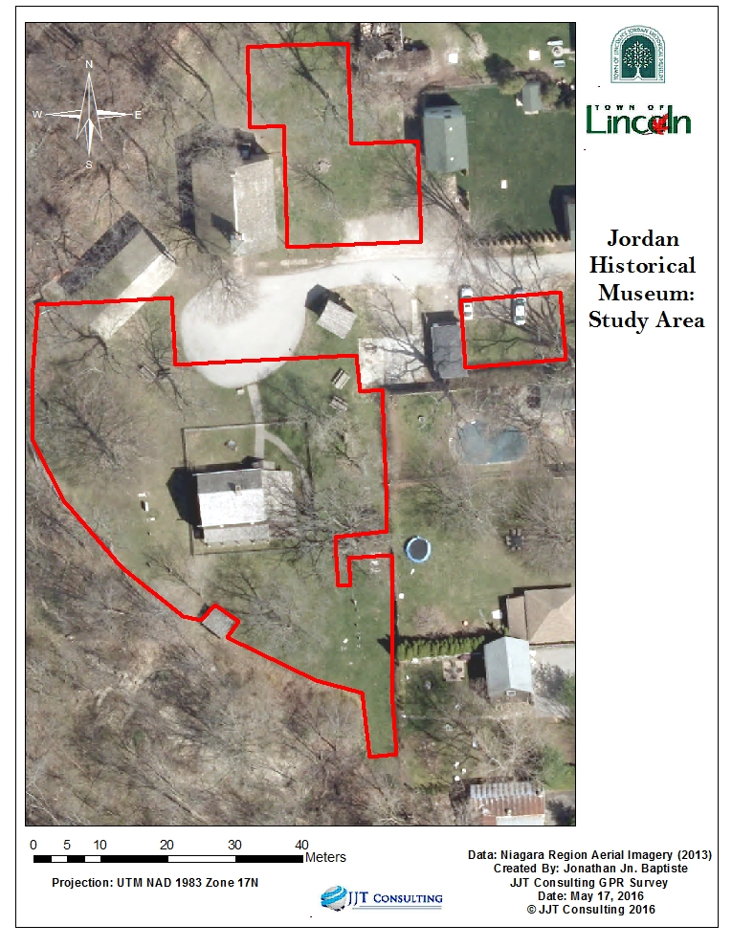

Figure 2 - Map of the Study Area

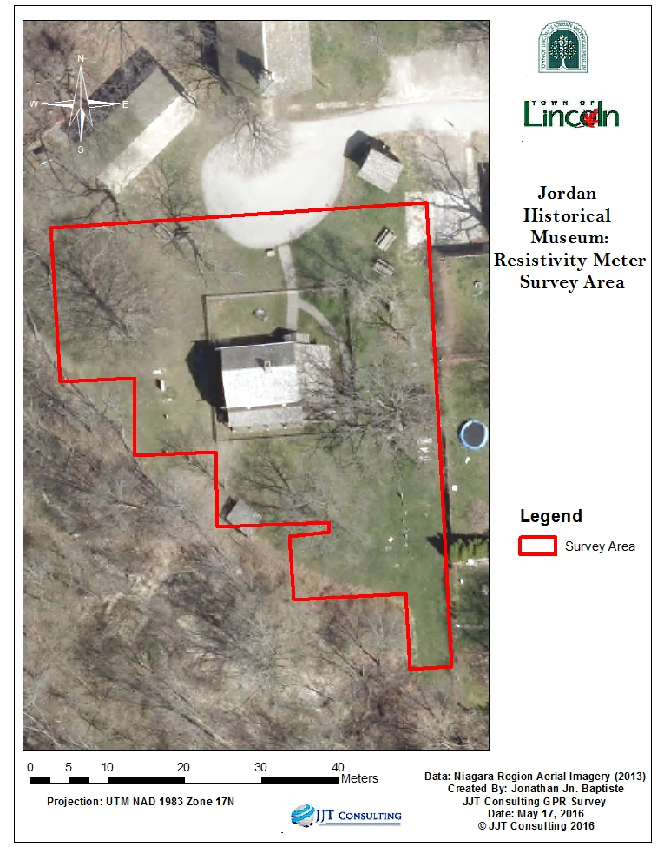

Figure 3 - Jordan Historical Museum Resistivity Meter Survey Area

## 1.3 Project Goal & Objectives

The initial project goal was to conduct a Ground Penetrating Radar (GPR) survey with the purpose of detecting possible human burial sites within the Jordan Historical Museum Site and map points of interest using available Geographic Information Systems (GIS). After equipment procurement was negotiated with Sustainable Archaeology and Western University, it became apparent that the project could be easily expanded to include an Electrical Resistance survey with no impact upon the ‘real’ project budget (equipment rental), but with a simple increase in time allotment. Given the benefit of using a second non-intrusive sensing technology, it was decided to expand the project scope to include the use of the Resistivity Meter.

### 1.3.1 Using GPR to detect interments

The use of the GPR enabled the project team to determine potential burial locations in the spring, after the snow melted, as operating in snowy and icy grounds was not feasible.

### 1.3.2 Mapping potential interment locations with GIS

Potential burial locations were determined through the GPR survey, combined with a Total Station used to capture the accurate locations of these sites. Map layouts were ultimately created using the GPR survey and Total Station results to reveal all potential burial locations.

### 1.3.3 Using a Resistivity Meter to aid with the GPR survey

Given the uncertainty of interments and their locations due to the age of the cemetery grounds, as noted above, the project scope was expanded to include the use of a Resistivity Meter was in conjunction with the GPR to help verify and detect possible burials.

# 2.0 Background

## 2.1 Museum History

The Jordan Historical Museum is located in the town of Lincoln, overlooking the Twenty-Mile Creek Valley. It was established in 1953 and began as a collaborative effort between Jordan Wines, previously called Danforth Wines Ltd., and the residents of Jordan Village, some of whom are descendants of the Pennsylvania German Mennonites. (Booth, 2013)

The Mennonites began arriving in Canada around 1776. They are a religious group established in Germany in the 16th century, when some Christians separated from the Roman Catholic Church because they viewed certain principles differently and had different beliefs. Their main issue was that they believed that infants should not be baptized and that baptism should be a mature, voluntary choice; hence their movement was termed Anabaptists. (Driedger & Epp, 2015)

Jacob Fry moved from Pennsylvania to Canada around 1800, first settling in Grimsby. He later moved to be closer to other Mennonite families who had settled in Vineland, a community within the Town of Lincoln. The Fry House was built in 1815. Jacob Fry and his family lived in this house until 1895 when a new brick home was built for the family a few yards away. (Booth, 2013) Figure 3 below depicts the Fry House in its current location:

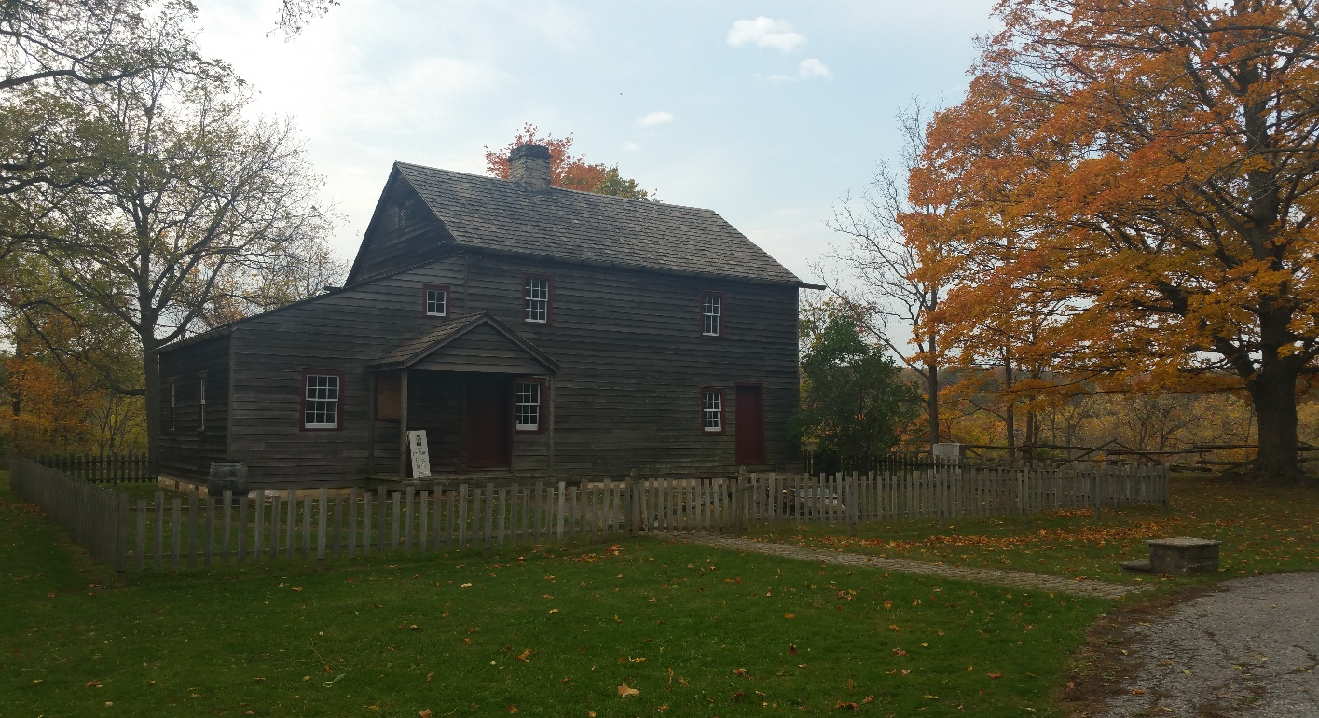

Figure 4 - The Fry House in its Current Location (Source: Jonathan Jn. Baptiste)

The site was believed to contain a Mennonite Cemetery, which was once associated with a Mennonite Church which was destroyed by a fire. The old Fry House was moved from its original location and restored on the grounds where the Mennonite church once sat in the 1950s (Town of Lincoln, 2015).

The Jordan Historical Museum Site is also home to other structures that tell a tale of the Mennonites and their lifestyle. The school house was built in 1895. It was used for 89 years until a more modern school could be constructed. The old school was restored in 1997, and is currently used as part of the museum’s tours, which allows visitors to experience what it was like to be in school in the 19th century.

The Administrative Building or Heritage House is used to showcase all aspects of the town’s history, including traditional Pennsylvania German folk art. It also houses a research library open to the public. However, in order to access archived material, an appointment needs to be made through the museum staff (Town of Lincoln, 2015), (Ontario Museum Association, 2015).

## 2.2 Literature Review

A literature review was undertaken to scope this project (Chan, Jn Baptiste, & Vanos, 2015).

The team examined previous studies on the effectiveness of using GPR to locate human burials. Both Schultz and Martin used adult pig burial to symbolize adult human burials as they are roughly the same shape and length (Schultz, 2008-2012), (Martin, 2010). These studies were observed under a controlled environment with the pig bodies buried in a grid system in graves that ranged from 0.5 to 1 meter deep. Schultz determined that a lower GPR antenna frequency (250MHz) was better than a higher frequency (500MHz) for locating results in soils that were wet (Schultz, 2008-2012).

Martin found in his study that pig carcasses buried in denser soils, such as clay, became more difficult to image with GPR after six months (Martin, 2010). Martin also confirmed that the 250MHz antenna frequency was better than the 500MHz frequency for surveying burials. “… the 250-MHz antenna provided better resolution of the burial scenarios than the 500-MHz antenna due to easier discrimination of the forensic targets. Therefore, the use of a 250-MHz antenna would be a viable option to search for clandestine burials containing adult-sized bodies.” (Martin, 2010) In addition, the lower frequency detected fewer anomalies than the higher frequency GPR unit.

Other research studied the combination of GPR frequencies with different types of soils, giving insight into different soil types and their effects on study areas (Mohamed Metwaly, 2007). Metwaly found that the density, texture, and moisture content of the soil would yield different results with different radar frequencies (Mohamed Metwaly, 2007). In particular, higher frequencies worked better with soils that had a low clay percentage, and that a lower frequency would be suggested for soils with more clay content.

Using resistivity meters to find graves has also been practiced by many archaeologists as it is a non-intrusive and efficient method of detecting graves. “It can give an idea of whether the soil disturbances are deep or not” (Whittaker, 2015). It should be noted that the soil type and strata will greatly affect the success of the results as it does with GPR surveys; each cemetery can yield different results. For example, in one cemetery, a high resistance indicated graves, while in another, lower resistance provided results for the locations of graves (Bevan, 1991). A study of a mass burial in Saipan found that conductivity meters were better than GPR as locating differences of soil, stones, and tree roots (Doolittle & Kashko, 1990). Weymouth and Jensvold’s study of a 1905 Wyuka Cemetery in Lincoln, Nebraska found that soil moisture content can greatly affect results. They noted the importance of using pre-existing grave markers to help differentiate the results of a grave and undisturbed soil (Weymouth & Jensvold, 1996). All literature research indicated that although resistivity meters are useful in aiding the location of burials, a GPR survey typically yields better results.

Archaeological sites that have trees on grounds are not only affected by the type of tree, but also by the tree roots and the tree coverage. Tree roots affected the soil acidity, texture, and moisture detainment (Crow, 2004). In his study, Crow noted that while tree roots often affect archaeological sites, most roots were removed without documentation and it was unknown how severe the damage may be in some cases.

The study area is dominated by the species of tree known as Black Walnut (*Juglans nigra*). Black walnut trees grow in fertile, lowland soils with high water tables, and Mennonites often settled in areas with black walnut trees. The nuts of the black walnut tree are edible, and the wood is known to be very durable. The roots, nut husks, and leaves secrete a toxin known as juglone, a respiratory inhibitor to other plants; it does not affect humans (Leuty, 2012).

## 2.3 Sustainable Archaeology

After contacting numerous equipment rental agencies, Sustainable Archaeology was chosen for the rental of both the GPR and resistivity meter instrumentation. Sustainable Archaeology is a collaborative initiative between Western University and McMaster University, funded by the Canadian Foundation for Innovation (CFI) and the Ontario Ministry of Research and Innovation (Ontario Research Fund) (Sustainable Archaeology, 2016). Mr. Edward Eastaugh, the primary contact for Sustainable Archeology, is based at the Western University.

The instruments were rented for 14 calendar days. After the surveys were completed, geoprocessing and digital analysis were performed at the lab at the Western University. Throughout the surveying process, Mr. Edward Eastaugh corresponded with the team regularly and greatly helped with the troubleshooting process (which will be further discussed in 7.0 Challenge Management).

# 3.0 Geophysical Exploration Methodology

The study consisted of a Ground Penetrating Radar (GPR) survey and an Electrical Resistance survey with the purpose of detecting and mapping possible human burial remains. Instrumentation was procured for 14 calendar days. The data were collected over the course of a 3-day period, see 7.0 Challenge Management. The short time frame reduced the effect of the environment and weather uncertainties on the survey. A single operator conducted the GPR survey, and a single operator conducted the Resistivity Meter survey for data collection consistency.

## 3.1 Grid Preparation

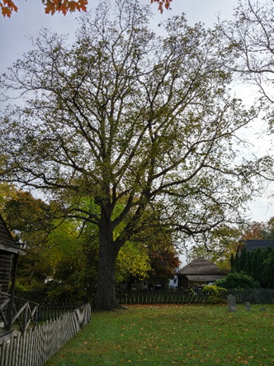Using fiberglass tape measures and survey markers, 10 m by 10 m square grids were measured and marked referencing a pre-existing fence to ensure best grid orientation for maximum coverage. Data were collected in an area of 1,800 m2 with 10 m by 10 m grid squares for electric resistance. GPR data were collected across the entire grounds (2,677 m2) in the same 10 m by 10 m numbered grids as often as allowed, modified out of necessity for avoiding large obstacles such as the walnut tree seen in Figure 5.

Figure 5 - Large Black Walnut Tree on East Side of Premises (source: Travis Vanos, May 2016)

## 3.2 Ground Penetrating Radar

A Ground Penetrating Radar (GPR) survey was completed over the total 2,677 m² of suitable terrain. The GPR unit consisted of a GSSI’s SIR-3000 system and a 400 MHz antenna mounted to a three-wheeled survey cart (see Figure 6). The original tow-cart (seen in Figure 8) with single survey wheel proved faulty and was replaced with the functioning push cart configuration (See 6.1 Equipment for a full discussion). Given the content of the soil, a 400 MHz antenna was used, which allowed the best signal penetration. A total of 31 grids were marked, arranged and traversed in either a north to south or east to west direction, depending on the traverse direction that would allow for the fullest or most accurate coverage of the site.

Figure 6 - Jessica Chan of JJT Consulting using GSSI’s SIR-3000 Cart System (source: J Jn. Baptiste, May 2016)

Whenever possible, grids were surveyed in the established 10 m by 10 m grid squares that were also used for the resistivity meter survey. This was completed to facilitate the process of analysing the data and correlating potential burial locations detected with both instruments. However, due to large obstacles and narrow areas, some additional grids were added to maximize coverage and prevent null data (Figure 7).

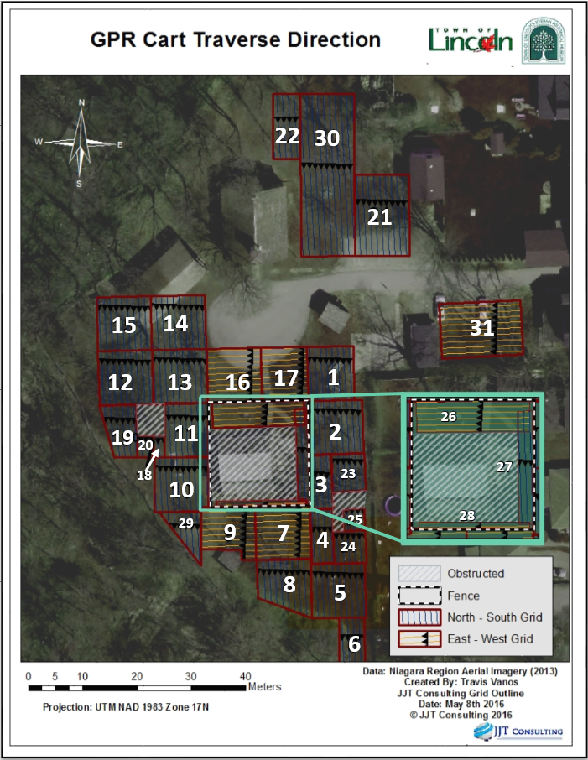

Figure 7 - Traverse Direction of Ground Penetrating RADAR Survey

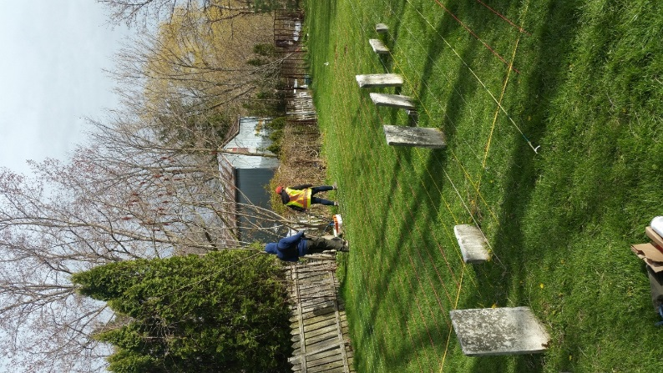Data were collected in linear transects at 25 cm intervals resulting in 41 transects per 10 m by 10 m grid (see Figure 8). When possible, grids were walked in a north to south direction to best detect burials that would be east to west facing, typical of Christian burials.

Figure 8 - Typical 10 m by 10 m Grid with 25cm Transects (Source: Travis Vanos, 2016

The depth of any discovered anomalies were estimated by the amount of time (in nanoseconds, nS) pulses from the GPR antenna took to travel through the medium given the relative permittivity, otherwise known as the “Dielectric Constant”, of the soil medium. The clay’s relative permittivity or Dielectric Constant, is the material’s property that describes the amount force between electrically charged particles (Coulomb’s Law), between two points, and how the charges decrease relative to permittivity of vacuum. The time length between transmitted pulses is called the “Time Window”, Tw , or the total travel time, two-way, the pulse travels to the reflectors back (Basson & al., Imaging of active fault zone in the Dead Sea Rift: Evrona Fault Zone as a case study, 2002).

“When converted to depth, the time window limits the maximum depth (or maximum range) of acquisition in the GPR profile. The transect depth profile, D, can be calculated as half of the time window, Tw , multiplied by the average propagation velocity, v , of the pulse inside the geological media (i.e *D ~ 0.5 Tw v*).” (Basson & al., Imaging of active fault zone in the Dead Sea Rift: Evrona Fault Zone as a case study, 2002; Basson, Mapping of Moisture Content and Structure of Unsaturated Sand Layers with GPR, 1999).

After a thorough literature review was completed to provide the most accurate depth estimation, the area was deemed to have a dielectric constant of 8 to estimate the depth of points of interest (Davis & Annan, 1989).

## 3.3 Resistivity Meter

To supplement the results of the GPR survey, an Electrical Resistance survey was added to the project scope, covering 1,800 m2 of the Jordan Historical Museum Site that were deemed to have a high potential for unmarked burials. Similar to GPR, Electric Resistance surveys are a non-destructive, non-intrusive technique for detecting burial shafts (Ellwood, 1990). The resistivity meter was used to detect the disturbances in soil by measuring the changes, in ohms (Ω), in electrical current/flow through the soil medium. Packed soil and grave soil resist electricity differently since they hold dissimilar moisture contents and thus are distinguishable from the surrounding undisturbed earth (Whittaker, 2015). Disturbed soils tend to have a higher moisture content, and therefore a lower resistance (Ohio Valley Archaeology Inc., 2016). Therefore, the resistivity meter was a great asset in correlating possible burial locations found in the GPR survey.

The survey was completed using a Geoscan Research RM 15 electrical resistance meter in twin-probe configuration. The mobile probes were spaced 50 cm apart and the distance from the remote probes was greater than 10 m at all times. A 40 volt (V) supply was used to apply a constant 1 milliamp (mA) current to the mobile probes. Data were collected in linear, north to south transects at 50 cm intervals resulting in an over-all sample density of 4 samples per square meter.

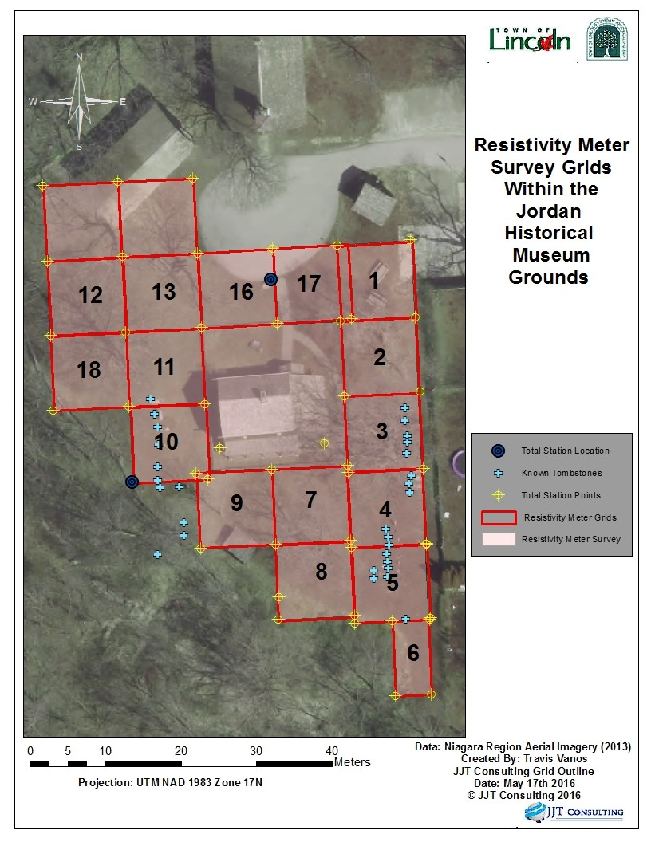

Figure 9 - Total Station Locations in Relation to the Resistivity Meter Grids

## 3.4 Geo-referencing and Ground Truthing

Using geo-referenced 2013 aerial imagery of the Lincoln/Jordan area (geographically correct to 0.10 metres on the surface of the Earth), a backsight was established for a topographic survey using an electronic Total Station. The Total Station survey (TSS) was conducted for geo-referencing surface features and testing (or “ground truthing”) subterranean anomalies detected through GPR and resistivity meter surveys. Several control points were established of large surface features, visible in aerial imagery to ensure positional accuracy with the total station before commencing survey.

After positional accuracy was validated, the co-ordinates of each 10 m by 10 m grid corner was recorded with the total station and imported into ArcGIS as seen in Figure 9, above.

For GPR ground truthing, flat surface tombstones (see Figure 10, below) with coordinates captured using the Total Station were surveyed and then overlaid on the aerial imagery to validate accuracy with the GPR cart.

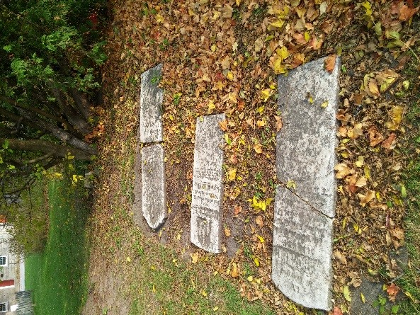

Figure 10 - Known tombstones on the study grounds (Source: Travis Vanos, 2016)

Figure 11 shows the known coordinates of surface tombstones in reference to GPR imagery.

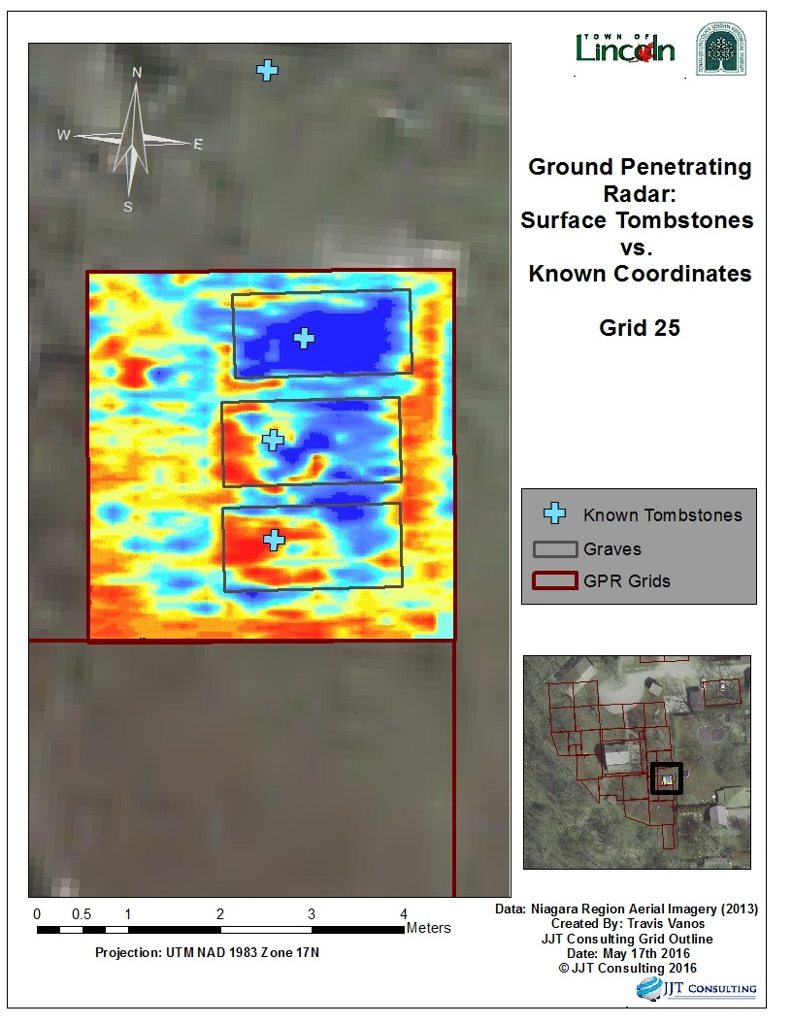

Figure 11 - Surface Tombstones vs. Known Coordinates

## 3.6 Data Analysis and Required Resources

The GPR survey provided data within individual files that were then processed with GSSI’s RADAN 6.0 software for rendering and analysis. The resulting data consisted of a Radargram profile captured for each transect in a two dimensional (2D) JPEG (.jpg) format. An entire grid was then viewed in a single, continuous 2D profile that concatenates transect profiles onto the previous in numerical order, see Figure 12.

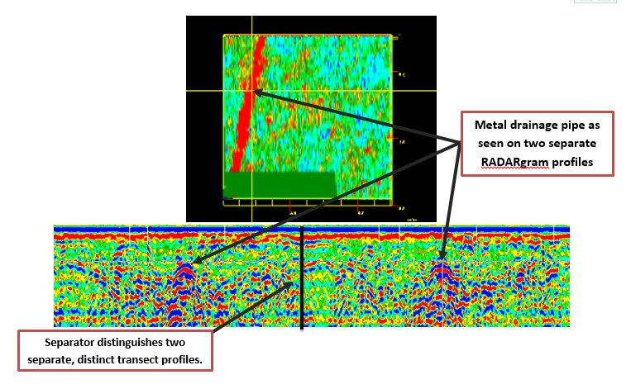

Figure 12 - GPR readings as seen in RADAN 6.0

It was not until all transects in a grid were processed and merged three-dimensionally that patterns and anomalies would be visible and fully understood.

Using a known, highly reflective subterranean feature, one can affirm GPR accuracy and ground truth anomalies. A possible drainage pipe on the premises was used as an identifiable feature that displays the accuracy of the transects as seen in Figure 12, above.

After processing, a 3D rendering of a grid was explored through the X, Y and Z (depth (nS)) data. Exploring the data, anomalies were seen and referenced to the correct transverse (or “slice”) that passed the area of interest. Disturbed soil is distinguishable from the surrounding earth as seen in Figure 13.

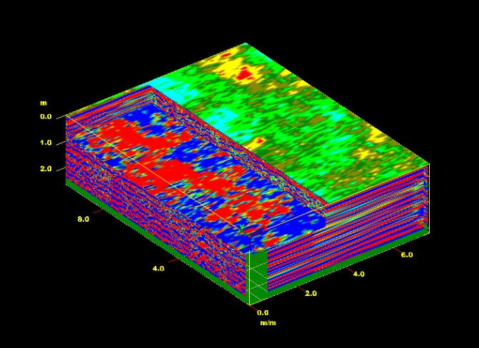

Figure 13 - Disturbed soil at approximately 1m

Disturbed soil could be seen at an approximate depth of 1 m which coincided with the expected burial depth of that era.

## 3.6 Resistivity Meter Data Analysis

After the resistivity meter survey was concluded, the data could not be analysed until they were extracted using the software provided at Western University. The information was uploaded successfully and each 10 m by 10 m grid was then saved as a greyscale JPEG with a resolution of four samples per 1 m2. The resulting images were then mosaicked together to for the final result to show the clear pattern of burials on the west side of the Jordan Historical Museum site (see Figure 14, below).

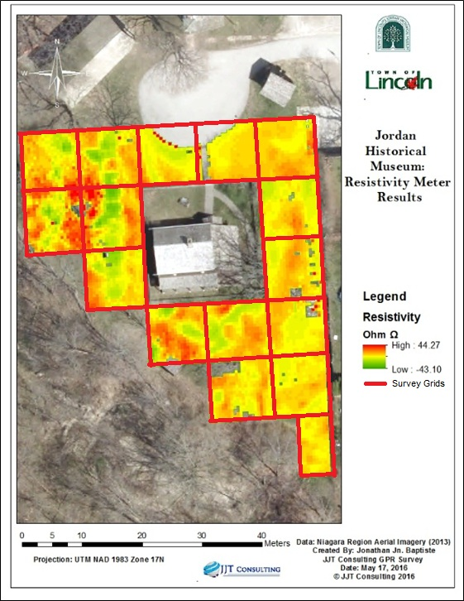

Figure 14 - Mosaicked resistivity meter results

# 4.0 Results and Analysis

## 4.1 Post Survey Data Processing

The results of the GPR and Resistivity Meter surveys were georeferenced onto the study area map to help create an understanding of the survey. The GPR results were catalogued at four different slices of time to showcase the Jordan Historical Museum Site at different set depths of strata. Table 1 shows the approximate wave penetration time in nanoseconds (nS) and depths (m) at which the GPR data were sampled.

Table 1 - Approximate nanosecond to depth penetration comparison

|  |  |
| --- | --- |
| **Approximate Nanoseconds (nS)** | **Approximate Depth (m)** |
| 10 | 0.5 |
| 20 | 1.0 |
| 30 | 1.5 |
| 40 | 2.0 |

Figure 14 to Figure 17 represents the GPR results at 10 nanosecond intervals from approximately 10 nanoseconds through to 40 nanoseconds.

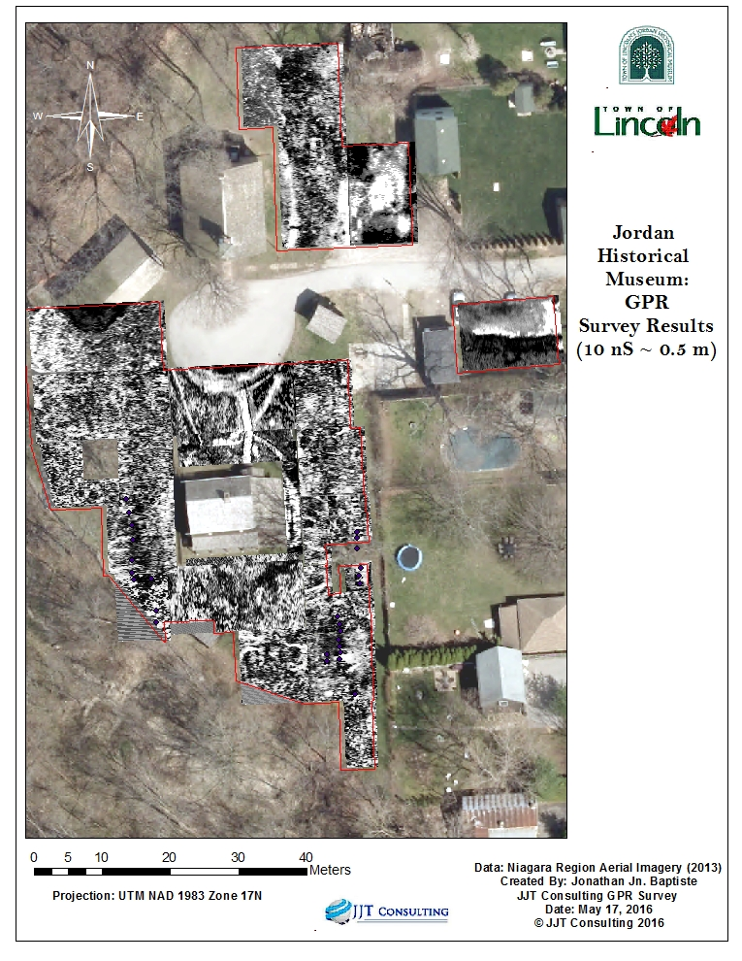

Figure 15 - GPR Survey Results at Approximately 10 Nanoseconds

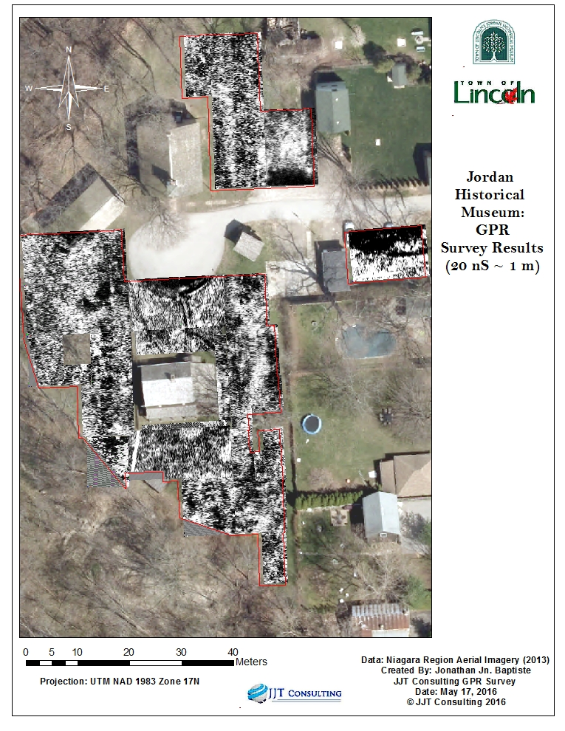

Figure 16 - GPR Survey Results at Approximately 20 Nanoseconds

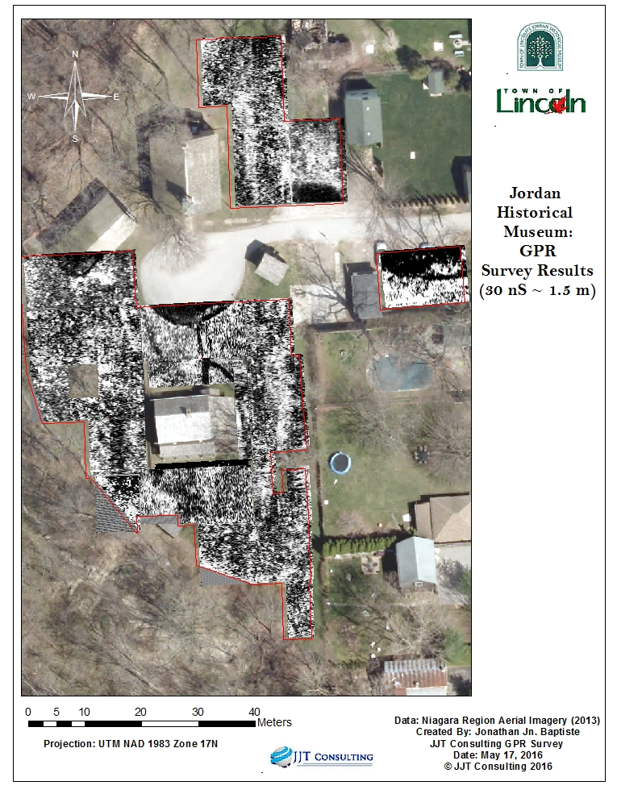

Figure 17 - GPR Survey Results at Approximately 30 Nanoseconds

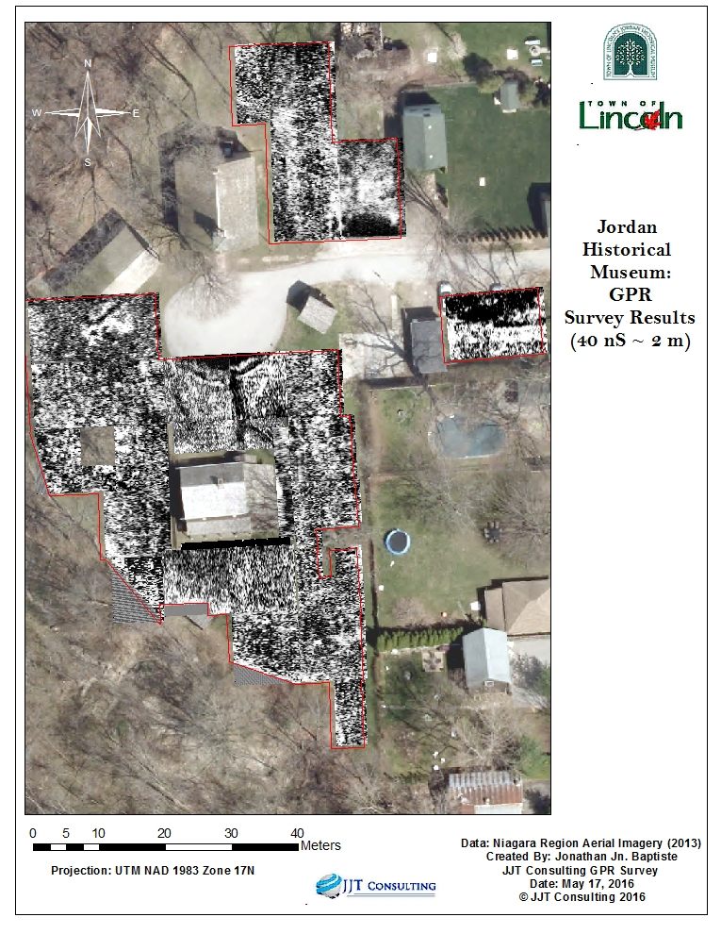

Figure 18 - GPR Survey Results at Approximately 40 Nanoseconds

After this set of maps was created, specific points of interests that were noted during the data processing were investigated further. These points of interest were also mapped according to their grid’s geographic coordinates. A more in-depth discussion of these points of interest with corresponding maps can be found in 4.2 Discussion and Summary of Results and Findings.

The results of the Resistivity Meter were relatively straightforward, showcasing the electrical resistance measured in ohms (Ω). Therefore, a single map layer was produced. The map showing the results of the Resistivity Meter survey can be seen below in Figure 19.

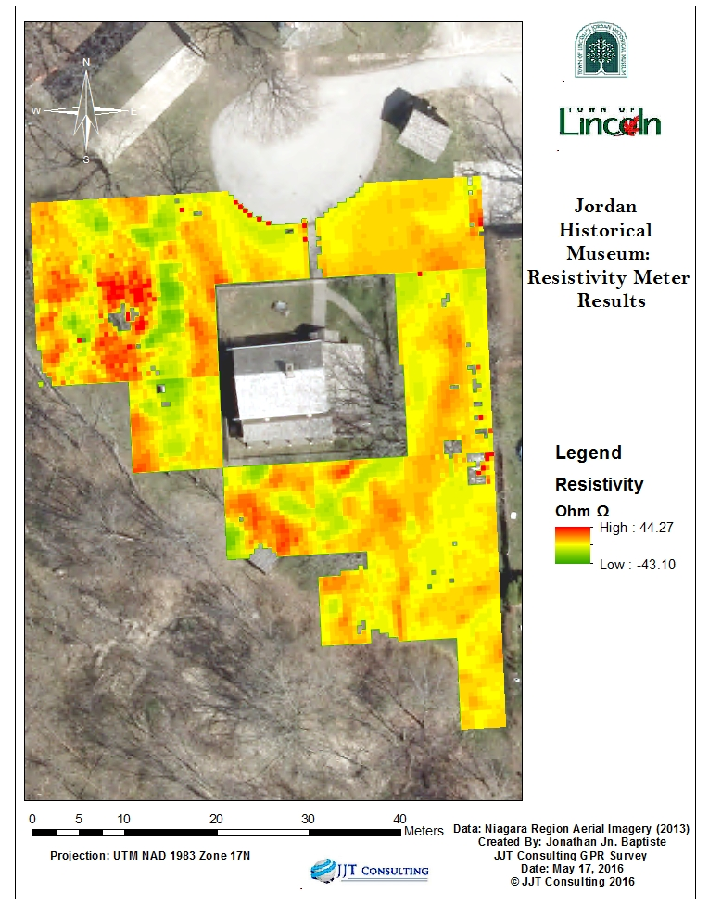

Figure 19 - Resistivity Meter Results

## 4.2 Discussion and Summary of Results and Findings

Findings are discussed in specific areas within the study site:

**Area west of the Fry House outside its surrounding fence**: It is known that there are a number of pre-existing tombstones in a relatively regular line (north-south) all facing the east-direction. Using both the GPR and the resistivity meter, a series of underground anomalies were discovered lined up in a similar fashion to the pre-existing graves. These subterranean anomalies appear regularly and extend north towards the cul-de-sac pavement area and south towards the south side of the building. The shapes of these underground anomalies are approximately 1 m by 2 m, which are similar to the known dimensions of regular burials. These anomalies can be seen at approximately 10 to 30 nanoseconds (roughly 0.5 m to 1.5 m in depth), but are clearest at about 20 nanoseconds (~1.0m in depth). This corresponds with the results of Schultz’s study of pig burials buried at 0.5 m to 1.0 m depths (Schultz, 2008-2012). Please see Figure 20 for a comparison of the GPR and resistivity meter results of the same area. The possible interment locations based on the GPR imagery can be seen in Figure 21.

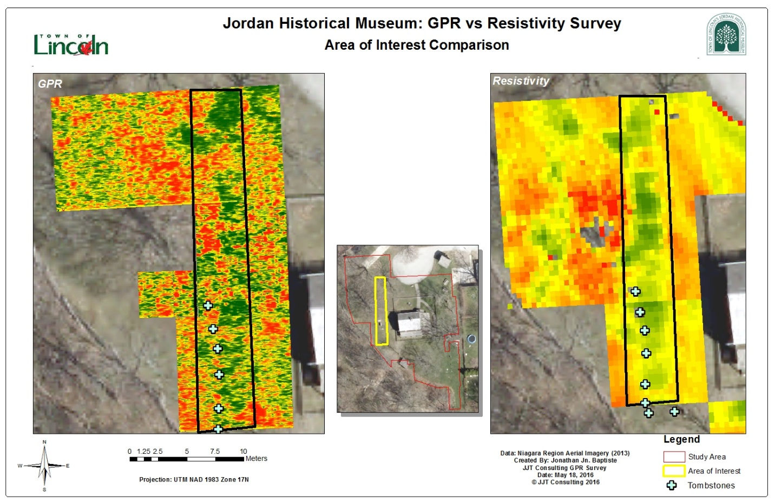

Figure 20 - Comparison of GPR and Resistivity Meter results of the area immediately east of the Fry House

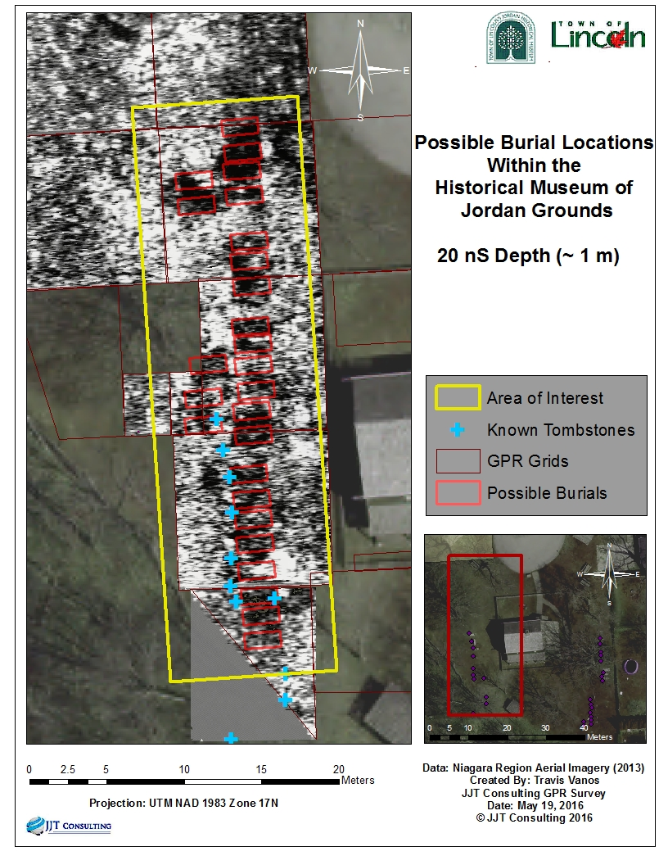

Figure 21 - Possible Burial Locations within the Historical Museum of Jordan Grounds - West side

Additionally, a tombstone was located in the cliff side approximately 10 m south of the previously discussed row of anomalies. It is possible that there may be unmarked interments that continue from the row of irregularities all the way to the tombstone. Figure 22 shows a picture of the tombstone set into the cliff side.

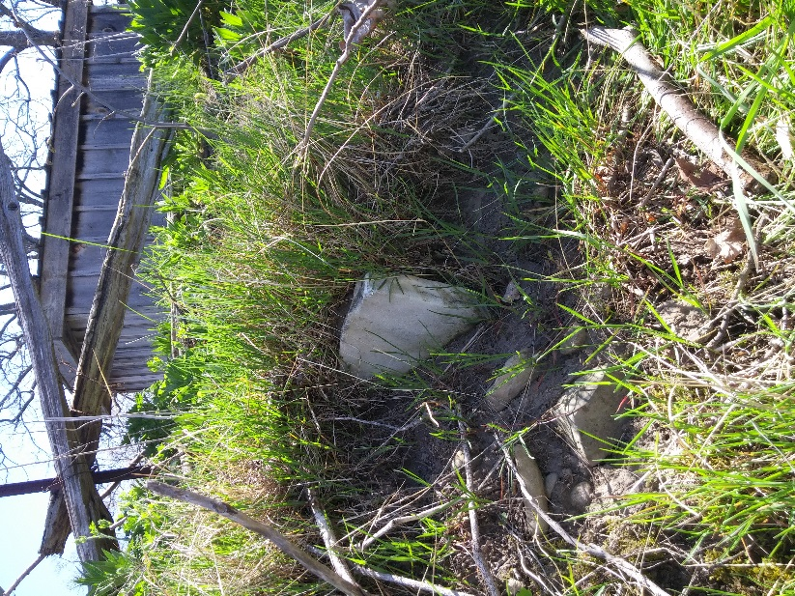

Figure 22 - Tombstone set into the cliff side (Source: Jonathan Jn Baptiste, 2016)

The map in Figure 23 shows the location of the tombstone in the cliff side relative to the anomalies previously discussed in this section.

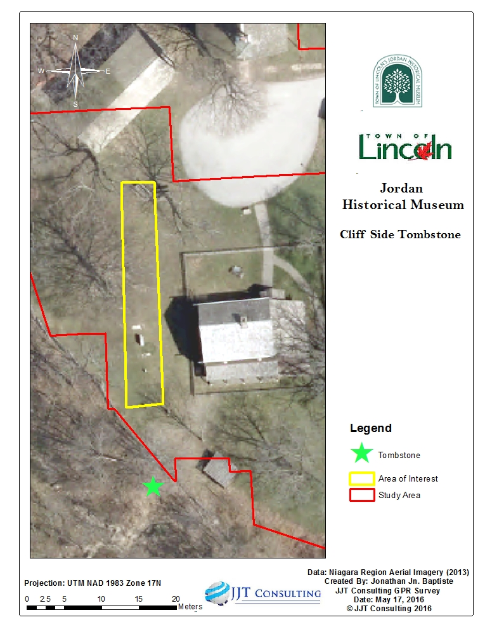

Figure 23 - Location of the tombstone on the cliff side

**Area immediately north of the Dr. Bowman mounting block, north of the Fry House:** Although the GPR signal was weakened by the pavement of the cul-de-sac, the GPR was able to detect an anomaly at approximately 10 nanoseconds (~0.5m in depth) north of the marker. The size of this subterranean rectangular irregularity is about 2 m by 3 m. It should be noted that the resistivity meter was unable to detect this anomaly and the results showed that the resistivity of this area to be generally the same as the immediate surrounding area. The map in Figure 24 illustrates the area of interest beside the Dr. Bowman marker.

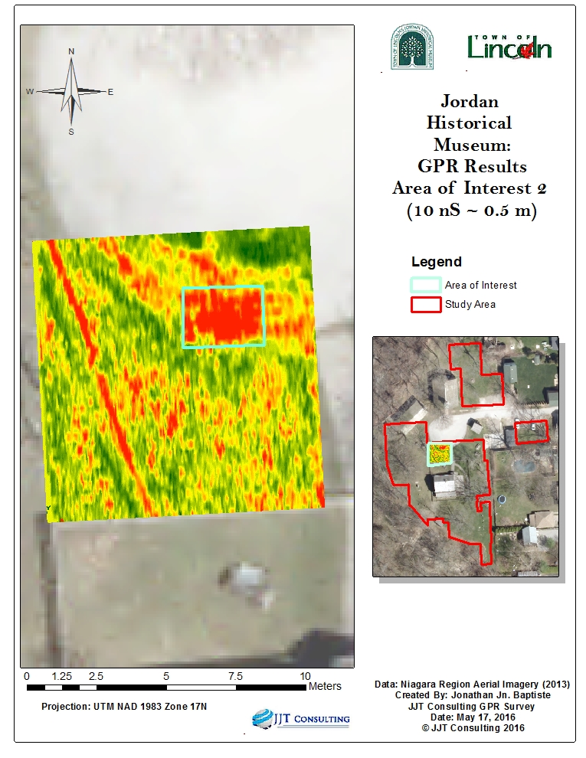

Figure 24 - Possible interment beside Dr. Bowman marker

**Area at the most eastern edge of the property immediately east of the black walnut tree:** There are a number of known grave markers aligned north-south, generally facing east. Based on the high reflection seen in the GPR results, it is possible that the row of unmarked interments proceeds north and south from the line of known existing tombstones. The high reflection suggests a solid object beneath the Earth’s surface. The size and shape of this reflection is about 1 m by 2 m in size, similar to the pre-existing grave markers and the other anomalies found west of the Fry House. Therefore, anomalies such as this are most likely buried grave markers. It should be noted, however, that the resistivity meter was unable to detect any change of electrical resistance in the soils around this area, due to an inability to pass current through the solid tombstone. The resistivity meter can only detect changes in soil, therefore, whenever the meter passed over a tombstone in the ground, a dummy log (or null value) would be logged in lieu of a soil reading. Southwest of the area of interest, where tombstones are visible, the GPR and resistivity meter were both unable to detect any subterranean anomalies. Figure 25 shows the location of these possible interments.

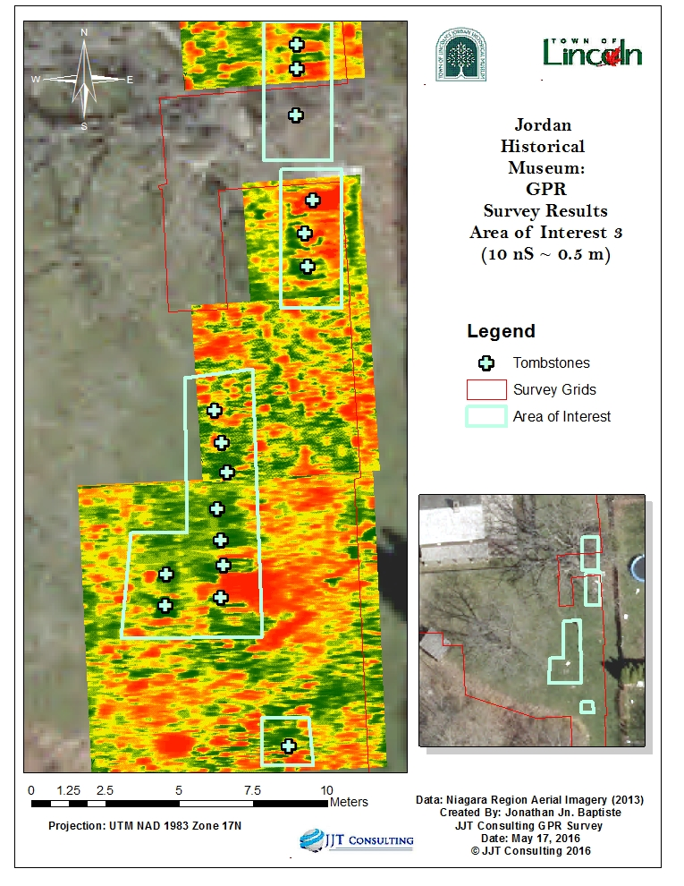

Figure 25 - Possible interments east of the Fry House

**Area immediately north of the Fry House, east of the present-day cobblestone path:** There is an arced anomaly intersecting the current cobblestone path leading directly to the Fry House from the cul-de-sac pavement seen in the GPR results at approximately 10 nanoseconds (~ 0.5 m in depth). Due to its distinct shape and location, it is highly possible that this curved anomaly is an old path. It is approximately 8 meters in length. The resistivity meter did not detect any differences in electrical resistance of the soil of the area in comparison to its general surround area. The area of interest can be seen in the map found below in Figure 26.

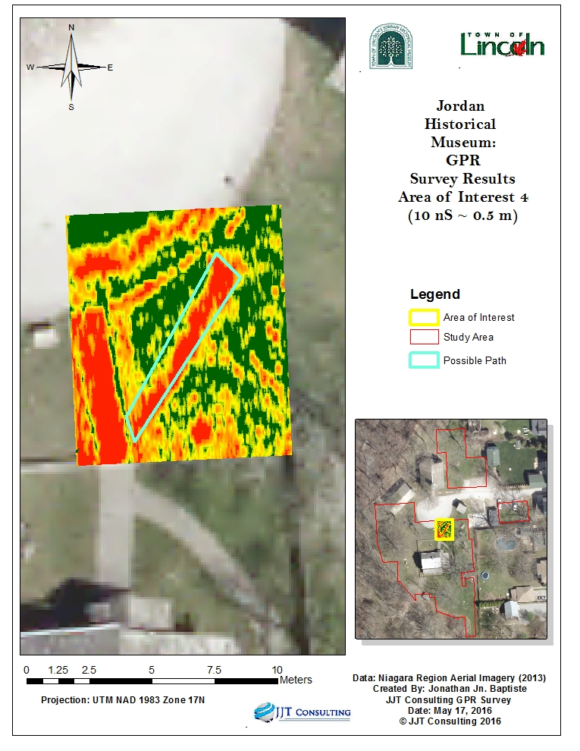

Figure 26 - Area of interest north of the Fry House, east of the cobblestone path

**Area within the fence of the Fry House and immediately south of the Fry House outside of the fence**:It is known that there was once a Mennonite church where the current Fry House is situated (Town of Lincoln, 2015). JJT Consulting was also informed by Mr. Ray Konkle, Vice-President of the Jordan Historical Museum of the Twenty Volunteer Association, that a possible location of the previous church foundation can be found north of the cobble-stone path as seen in Figure 27 (Konkle, 2016). The GPR was unable to confirm the exact location of the foundation within the fence. However, in the area south of the Fry House immediately outside fence, a triangular anomaly with a base of approximately 13 m (running east-west) and a height of approximately 9 m (north-west) was discovered. Given its size, shape, and the knowledge of the former church foundations, this is most likely part of the church’s foundation. Figure 27 shows the triangular anomaly. Foundations and paths were not included in the Electrical Resistivity survey, Electrical Resistivity was used for interment detection solely.

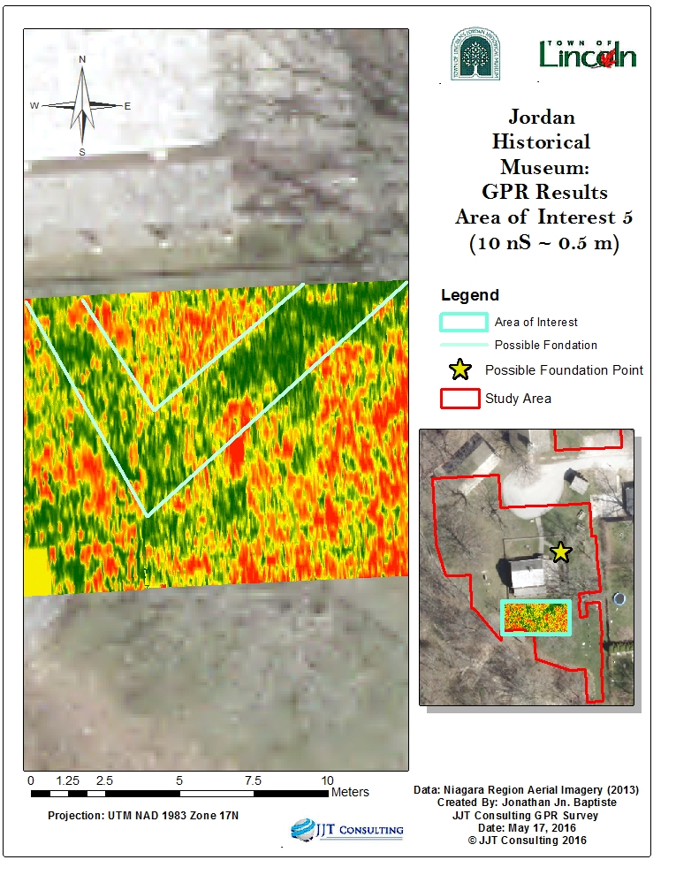

Figure 27 - Possible Foundation of old Mennonite Church

**Area east of the schoolhouse:** Through the GPR survey, a large relatively rectangular anomaly measuring approximately 6 m by 10 m was found east the schoolhouse. Due to its size and shape, it is possible that this area was a foundation for a barn that once existed on the property. Immediately east of the school house, there is a long arced anomaly marking approximately 15 m in length. According to Ms. Helen Booth, this irregularity is most likely an old path (Booth, Personal Conversation , 2016). Both the rectangular and semi-circular anomalies are best seen at approximately 10 nanoseconds or about 0.5 m in depth. The map shown below in Figure 28 shows the location of this possible foundation beside the schoolhouse.

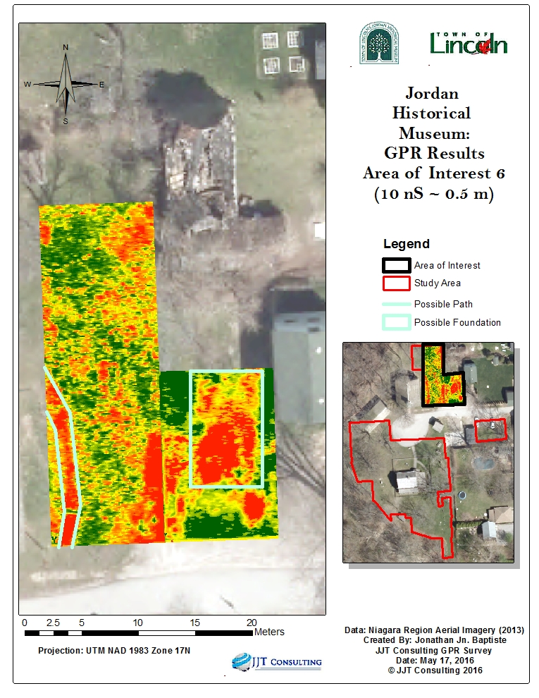

Figure 28 - Possible old path and foundations by the schoolhouse

Several areas of interest were found with the GPR. These findings could not always be seen through an electrical resistance survey as the soil content was not altered, and only the GPR wave reflections are highly visible. Evidence exists for a burial area on the premises along the west-side of the Fry house. A portion of this area contains no grave markings. This burial area can be seen as a uniform, linear pattern that coincides with the known tombstone locations (see Figure 20 andFigure 21). The area thought to contain unmarked burials is primarily concentrated in a **400 m²** area of interest that occupies GPR grids 10, 11, 13, 18 and 29 (refer toFigure 7). Although distinguishable through GPR, the burials could also be identified through electrical resistance as seen in resistivity meter grids 10, 11 and 13 (see Figure 9). The pattern of conductive soils that indicated a potential burial shaft highlighted the same burial pattern and size as the disturbed soil detected through the GPR survey (see Figure 20). A total of 26 anomalies were marked are thought to be contained in the area of interest (seeFigure 21). The area extends from the cliff face (Figure 22). The potential interments in relation to the proposed redevelopment site plan can be seen in Figure 29.

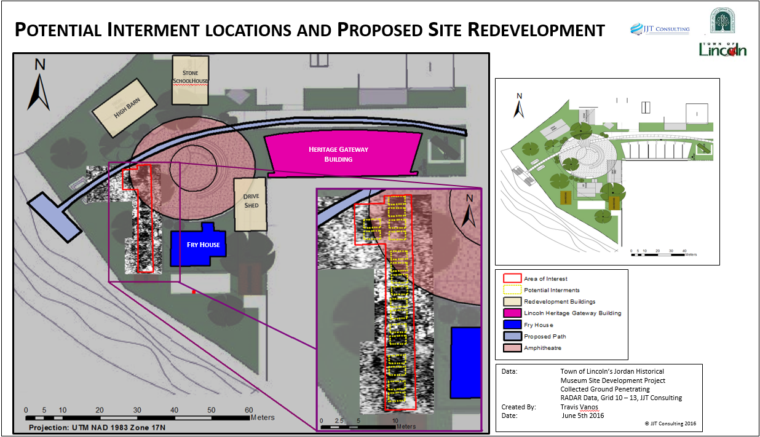

Figure 29 - Potential Interment Locations and Proposed Site Redevelopment

# 5.0 Project Management

## 5.1 Schedule

Within the project proposal, a schedule was set, outlining the tasks that needed to be completed to achieve the project goal (Chan, Jn Baptiste, & Vanos, 2015). Table 2 below presents the list of all the major tasks, the revised completion date and the status of each task’s completion. As of May 27, 2016, the project was 100% complete. After the completion and submission of the report, a presentation of the project will be given once at Council Chambers at the City Hall of Lincoln and again at the Glendale Campus of Niagara College.

Table 2 - Schedule of Major Milestones

|  |  |  |  |
| --- | --- | --- | --- |
| **Milestone** | **Original Target End Date** | **Revised Date** | **Completed** |
| Meet with client | 22-Oct-15 |  | ✓ |
| Establish project scope, objectives and benefits | 22-Oct-15 |  | ✓ |
| Develop Project Overview Statement | 22-Oct-15 | 11-Jan-16 | ✓ |
| Present Project Proposal | 7-Dec-15 |  | ✓ |
| Develop Project Proposal Report | 11-Dec-15 | 18-Jan-16 | ✓ |
| Collect Sources for Literature Review | 1-Feb-16 | 25-Feb-16 | ✓ |
| Develop Literature Review | 8-Feb-16 | 10-Mar-16 | ✓ |
| Present Project Progress Status | 17-Mar-16 |  | ✓ |
| Report on Project Progress | 18-Mar-16 |  | ✓ |
| Training for Equipment | 29-Mar-16 | 25-Apr-16 | ✓ |
| Acquire Project Data | 18-Mar-16 | 25-Apr-16 | ✓ |
| Conduct GPR Survey | 3-May-16 | 25-Apr-16 | ✓ |
| Geoprocessing and data analysis | 27-May-16 | 7-May-16 | ✓ |
| Develop map of Jordan Historical Museum Site | 6-Jun-16 | 10-May-16 | ✓ |
| Review of project milestones | 1-Jun-16 | 23-May-16 | ✓ |
| Deliver Final Report to client and present findings | 17-Jun-16 | 27-May-16 | ✓ |

The Project Phases’ Completion Dates and its subsequent Approval Dates by Ms. Helen Booth are outlined in Table 3 below. Please note that Milestone 3: Final Report and Presentation and Project End Date have yet to be approved by the client and will be updated once approved.

Table 3 - Project Phase Completion Dates and Approval Dates

|  |  |  |
| --- | --- | --- |
| Project Phases | Completion Date | Approval Date |
| Project Start Date | 2015-10-15 | 2015-10-15 |
| Milestone 1: Project Proposal and Presentation | 2015-12-17 | 2016-01-19 |
| Milestone 2: Progress Report and Presentation | 2016-03-18 | 2016-04-22 |
| Milestone 3: Final Report and Presentation | 2016-06-08 | 2016-06 |
| Project End Date | 2016-06-08 | 2016-06 |

Table 4below, gives a list of completed major project tasks, their descriptions, and the associated theoretical approximate costs. These theoretical costs were approved by Ms. Helen Booth through each major milestone and biweekly reports. It corresponds with the Work Breakdown Structure (WBS), found in. The hierarchical structure corresponds with the major project phases and the tasks to complete each phase.

Table 4 - Major Project Tasks

|  |  |  |  |
| --- | --- | --- | --- |
| WBS Code | Task Name | Definition | Fees |
| 1 | Project Initiation | The work to initiate the project. | $2,391 |
| 2 | Project Planning | Preliminary Project Proposal/Scope. | $4,035 |
| 3 | Project Execution | Identify & Validate data requirements; Research appropriate technical solution;Complete Progress Report; Procure Software/ Instrumentation; Operations Training; GPR Survey/ Data collection; Assessment of measurements: Digitizing and Geoprocessing. | $47,426 |
| 4 | Control/Analysis | Project Management (Project Meetings, Bi-weekly Client Status reports, Academic Advisor Meetings, Project Management Plan Updates, Risk assessment/management. | $12,466 |
| 5 | Closeout | Audit Procurement; Document Methodology/Lessons  Learned; Front of House/Presentation; Gain Formal  Acceptance; Archive Files/Documents | $12,200 |

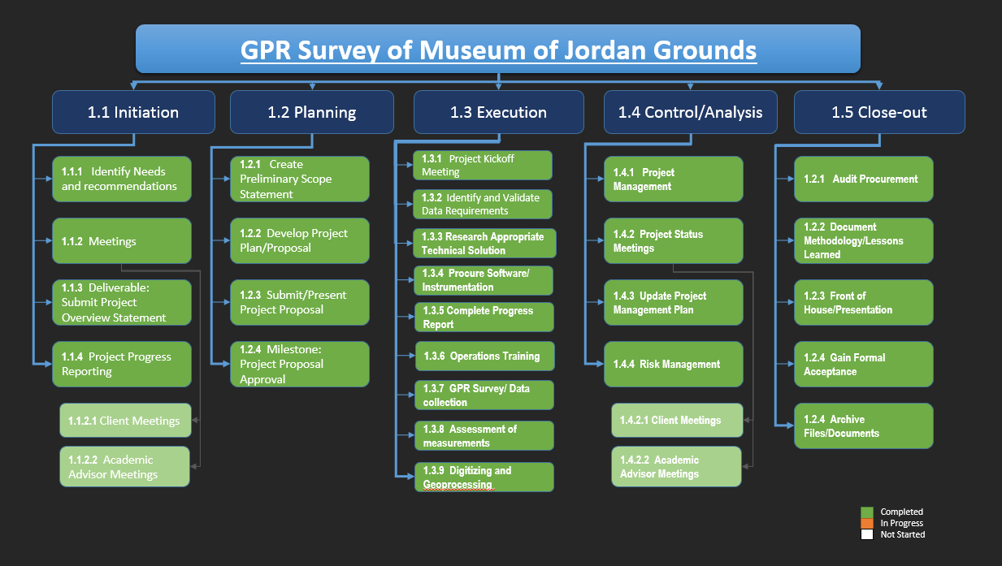

Figure 30 - Work Breakdown Structure of Project

## 5.2 Final Cost Update for GPR Survey of Museum of Jordan Interments

The project was initiated through the act of identifying the required data. To this end, staff of the Jordan Museum and the Town of Lincoln were interviewed to determine the data needs and conduct a survey of the grounds completing subsequent tasks and milestones the work entails.

The project is in turn completed and a total of **903.5 hours** have been expended. The original cost estimate and final updated cost were approved through major milestones and biweekly reports submitted to Ms. Helen Booth.

Table 5 details the total of all labour and costs for the entirety of the project:

Table 5 - Total Cost of Proposed GPR Survey

|  |  |  |  |
| --- | --- | --- | --- |
| **Project Start Date** | Thu 10/15/15 | **Project Start Date** | **Thu 10/15/15** |
| **Project Sign-off** | Fri 6/10/16 | **Project Sign-off** | **Fri 6/10/16** |
| **Proposed Time** | 338.57 hrs | **Time (person hours)** | **903.5 hrs** |
| **Proposed Cost** | **$33,515.43** | **Updated Cost** | **$90,228.24** |

## 5.3 Budget

**\*Please note: The budget presented in this report is for learning purposes only; the client is in no way expected to incur these costs. The value of this project is being donated to the client by the student consultants, Niagara College and the advisory staff.**

Table 6 outlines the updated total number of hours and cost of labour provided by JJT Consulting.

Table 6 - Total Cost of the Project

|  |  |  |  |
| --- | --- | --- | --- |
| **JJT Consulting Fees** | | | |
| **Project Member** | **Pay/ Hour** | **Total Hours** | **Total** |
| **Jessica Chan** | $80.00 | 290 | $23,200.00 |
| **Travis Vanos** | $80.00 | 306 | $24,448.00 |
| **Jonathan Jn Baptise** | $80.00 | 227.5 | $18,200.00 |
| **Ian Smith** | $150.00 | 80 | $12,000.00 |
| **Total Labour** | | | **$77,848.00** |
| **Instrumentation Costs** | | | **$2,000.00** |
| **Total (before tax)** | | | **$79,848.00** |
| **Tax (13%)** | | | **$10,380.24** |
| **Total Cost** | | | **$90,228.24** |

In addition to the labour costs, a “real” value of $2,000 was budgeted for the procurement of the GPR unit used for the duration of the survey. After instrumentation costs and taxes, the total project cost was determined to be $**90,228.24**. A standard rate for all persons of $80/hour, with the exception of Ian Smith, the Academic Advisor, who charged a rate of $150/hour, has been applied for the works of the project.

In total of 903.5 hours were expended on this project, totalling $79,848.00 before applicable taxes and fees. This information is outlined in Table 6 below. The following assumptions have been made during the calculation of the budget:

* The funds for this project are to be paid upfront by the Township of Lincoln,
* A real cost of $2,000 is allotted to the GPR unit and is included in the Project Instrumentation Costs,
* All prices are in Canadian Dollars,
* All product prices are valid as of January 18, 2016, and
* All data and findings will be transferred to the property of the Museum of Jordan upon completion of the project.

## 5.4 Earned Value Management (EVM)

The Earned Value Management (EVM) chart, as seen in Figure 31 measures the Earned Value (EV) against the Planned Value (PV) and the Actual Cost (AC).

Figure 31 - Earned Value Management Chart

Earned Value (EV) has been closely monitored since February, at which time all previous EV and Actual Cost (AC) from October was also included. The EVM chart was subsequently updated for the duration of the project. Biweekly updates were provided to both the thesis advisor and the client. It should be noted that the Actual Cost far exceeds the original Planned Value as the Project Scope was changed to include the Electrical Resistivity survey. Additional study areas beyond the original agreement were also included. These factors significantly increased the amount of survey time required to complete the survey. However, it should be observed that valuable data were gained from the additions to the survey, within the schedule allotted for the study.

# 6.0 Challenge Management

## 6.1 Equipment

**Challenge:** The team faced some technical issues regarding the odometer on the wheel of the GPR tow cart acquired from Sustainable Archaeology. Aside from the unit being incorrectly calibrated, the odometer was also logging the data inaccurately. The two aforementioned factors caused the resultant data to appear “stripey” (see Figure 32 for a comparison of faulty data versus desired data).

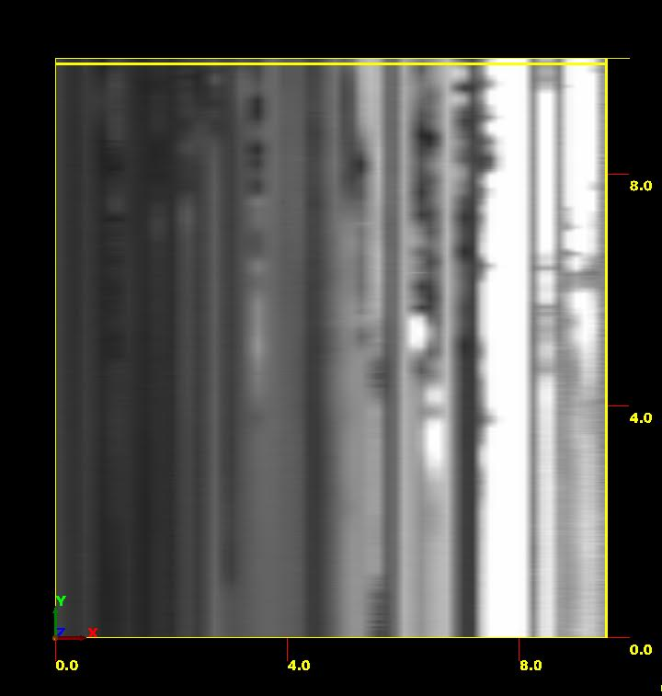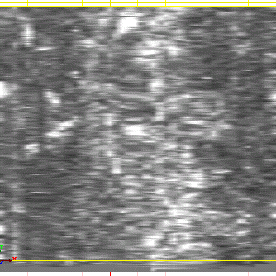

Figure 32 - On the left -"Striped" results of Grid 2 from the original tow cart; on the right – results of Grid 2 using the push cart

**Management:** After many failed results from test trials and running the machine on a control grid on loamy sand (which will be further discussed in 7.4 Soil Composition below), Mr. Edward Eastaugh from Sustainable Archaeology advised the team to change the equipment. Therefore, the tow cart was returned to Sustainable Archaeology in exchange for the push cart. The push cart was able to log the data correctly and efficiently. Figure 33 shows the two differing GPR platforms used.

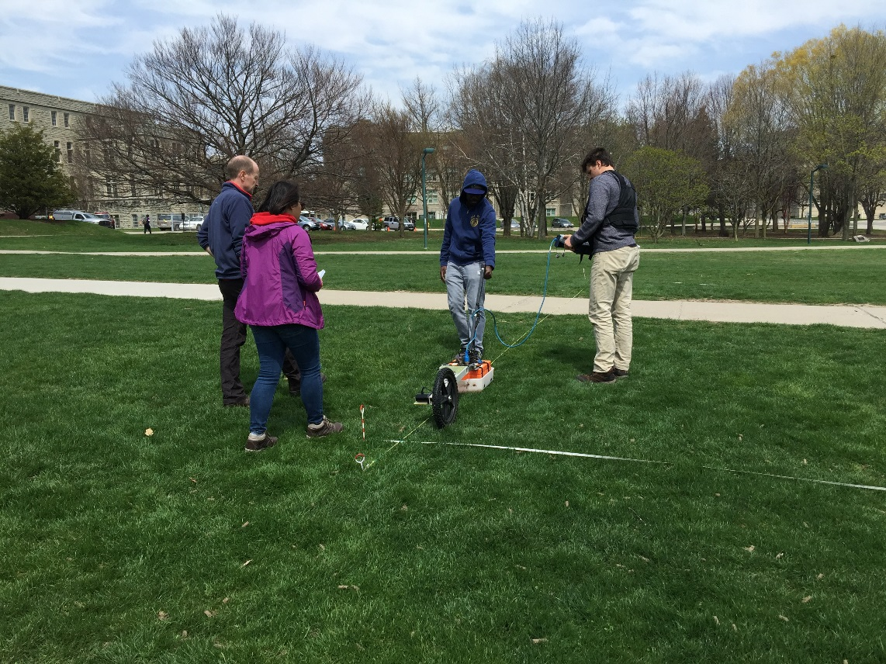 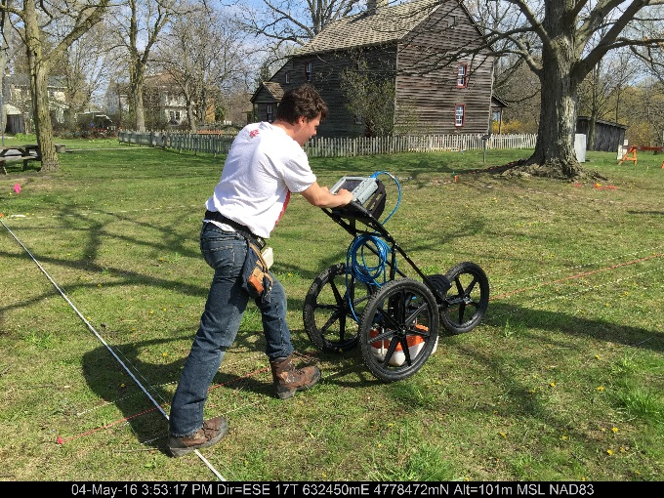

Figure 33 - Tow Cart (on the right) and Push Cart (on the left) (Image source: Ian Smith, 2016)

## 6.2 Software Availability

**Challenge:** The software used for processing the GPR and resistivity meter data was only available at Western University through Sustainable Archaeology.

**Management:** The team looked into obtaining open-source software for processing the results at the GIS lab at Niagara College. However, none of the software was capable of amalgamating the data in a format suitable for data analysis. Two separate data processing efforts were carried out; one to process the Resistivity Meter results, and another to process the GPR results. With efficient time management, the team was able to process each set of results during their trips to Sustainable Archaeology.

## 6.3 Interment Location and Obstructions

**Challenge:** Given the organic growth of the area, there were numerous obstacles, such as trees, bushes, and natural form of the cliff face at the edge of the property. The positions of the tombstones, the location of the Fry House, and its surrounding fence also affected the manner in which the survey was conducted.

**Management:** Smaller grids were added around large obstacles to maximize coverage. The 10 m by 10 m grids were divided into smaller grids, boxing in the large obstacle. It was essential to keep the equipment as close to the grounds as possible to avoid incorrect data collection. All corners of the grids were surveyed using the Total Station, input into ArcMap, and overlaid on aerial imagery. Therefore, it was known which areas of the site were surveyed and which were not.

For smaller obstacles, such as tombstones, the cart was either driven over the obstacle, or steered as close to the obstacle as possible. Despite the differences in traverse distances, the data was corrected according to the grid and traverse information configured using the processing software at Western University.

## 6.4 Soil Composition

**Challenge:** The soil composition of the study area as shown in below in Figure 34, is that of Silty Clay. It was known that soils with higher clay composition (see 2.2 Literature Review) may cause problems in the GPR survey. Clay soils are typically denser and wetter, thereby making it more difficult for RADAR to penetrate.

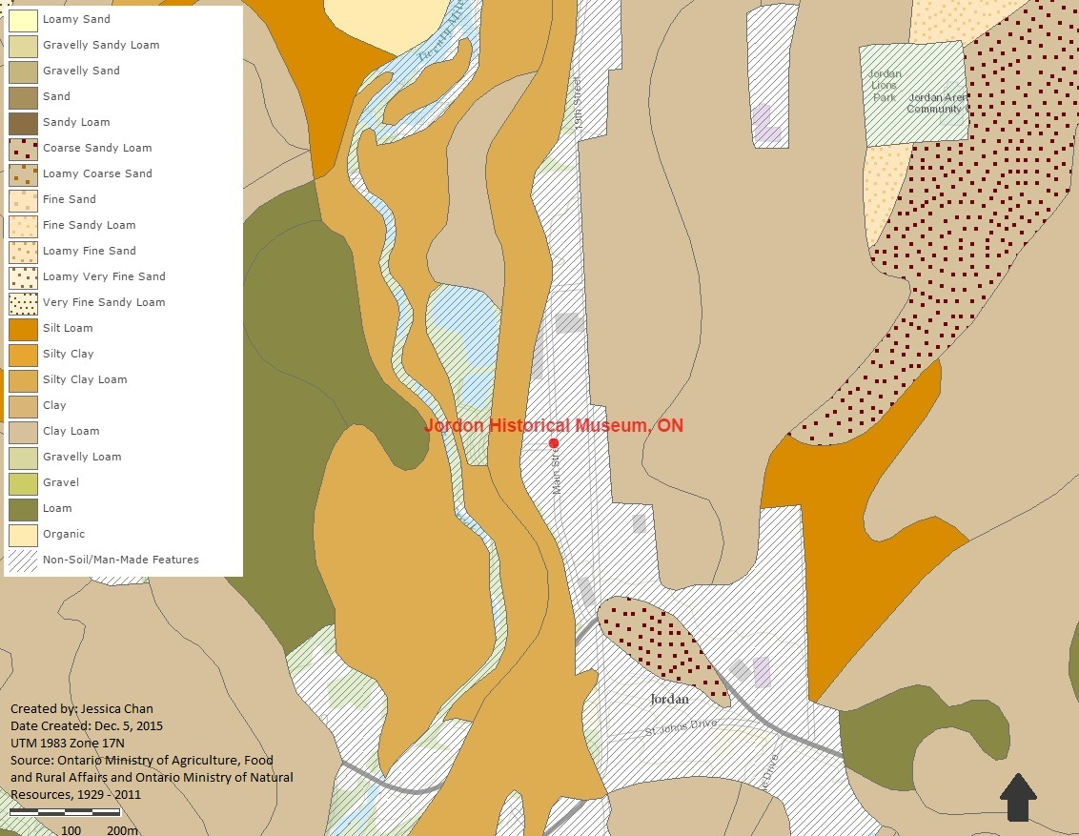

Figure 34 - Map of the Soil Composition in the Area

**Management:** The team performed extensive research to understand how to mitigate this issue (as seen in 2.2 Literature Review). The team was advised by Sustainable Archaeology that the 400MHz antenna was capable of performing the survey. Although a lower frequency antenna, such as a 250MHz antenna, would provide deeper results, the resolution of the data would be significantly decreased. Alternatively, a higher frequency antenna would not be able to penetrate the data and only reflect the data.

Additionally, the team performed a control test grid on an area known to have loamy sand soil composition where the underground anomalies, such as drainage pipes, were already known. These results were sent to Sustainable Archaeology for processing which allowed the team to understand the differences of known anomalies between the two different types of soils.

# 7.0 Closure and Discussion

The Ground Penetrating Radar (GPR) and Electrical Resistance survey has revealed subterranean anomalies that indicate the presence of interments and other areas of interest that relate to the site’s history. After concluding both Ground Penetrating Radar and Electrical Resistance surveys, compelling evidence exists for a burial area, previously unknown, on the site along the west-side of the fry house (see Figure 21). The area of interest, approximately 400m2 in size, is believed to contain up to 26 burials as the area exhibits the following criteria:

* A distinguishable pattern of anomalies that coincides with the known tombstone pattern
* Subterranean anomalies positioned east-west
* Similar, identifiable disturbed soil patterns visible in both Electrical Resistance and Ground Penetrating Radar surveys
* Anomalies approximately 1 m x 2 m in size which coincides with burial shaft size

The Electrical Resistance survey provided valuable data that correlates with the results produced through the GPR survey. Despite the silty clay soil and high water content of the soil medium, both the 400 MHz GPR antenna and the resistivity meter proved capable of producing tangible results. With a limited timeframe, more accurate results may have been achieved if the survey could have been performed in drier soil. Furthermore, an additional electrical resistance survey, with a smaller sample size and larger grid size in the area of interest may also aid in the definition of burial extents. However, the extent of this survey was limited by a deadline for findings.

The GPR survey revealed more information about subterranean anomalies than could have been detected through an electrical resistance survey alone. The Electrical Resistance survey, when used for this study, provided many benefits including but not limited to:

* Validate the findings produced with the GPR and discover similar anomaly patterns
* Minimal data-processing requirements
* Minimal image interpretation and processing to determine the area of interest with potential interments
* Identify potential burial location and shaft size discovered with the GPR.

The pattern of conductive soils that indicate potential burial shafts highlights the same burial pattern and size as the disturbed soil detected through the GPR survey (see Figure 18). Both GPR and electrical resistance surveys provided a non-intrusive and effective alternative to traditional archaeological excavation.   
  
If a similar study was to occur, JJT Consulting recommends the use of both resistivity meter and the GPR technologies. The resistivity meter, when used in conjunction with the GPR, can be used to validate the survey results. Although this study used the same grid size for both GPR and resistivity meter, one can determine the grid size for maximum location coverage. A control grid on known soils in a different location is highly recommended. Finally, one should allocate sufficient time to accommodate possible challenges that arise during the surveying period.

# 8.0 Recommendations

An area of interest, approximately 400m2 in size, is believed to contain up to 26 burials. Referring to Appendix 2, The *Town of Lincoln’s Jordan Historical Museum Site Development Project,* the extent of this area would interfere with a proposed amphitheatre. In the presented areas of interest it is believed historical building foundations, artifacts, or other interments may be present in the aforementioned areas.

The Ontario Ministry of Tourism, Culture and Sport provides a checklist “*Criteria for Evaluating Archaeological Potential*” (form 0478E) that provides the criteria necessary for a site to require archaeological assessments(Ontario Ministry of Tourism, Culture and Sport, 2015). JJT consulting has determined is ‘Yes’ to many questions that are applicable and thus an archaeological assessment is advised for this site. For assistance in interpreting the questionnaire or advice on undertaking an archaeological assessment, it is advisable to hire a licensed consultant archaeologist (See Glossary for definitions). For further site development, the following advice can be provided to ensure compliance with legislation:

1. In accordance with part IV of the Ontario Ministry of Tourism, Culture and Sport Ontario *Heritage Act, R.S.O. 1990, c 0.18,* the archaeological fieldwork and subsequent reportrecommendations ensure the conservation, protection and preservation of the cultural heritage of Ontario. When all matters relating to archaeological sites within the project area of a development proposal have been addressed to the satisfaction of the Ministry of Tourism, Culture and Sport, a letter will be issued by the ministry stating that there are no further concerns with regard to alterations to archaeological sites by the proposed development.
2. It is an offence under Sections 48 and 69 of the Ontario Heritage Act for any party other than a licensed archaeologist to make any alteration to a known archaeological site or to remove any artifact or other physical evidence of past human use or activity from the site, until such a time as a licensed archaeologist has completed archaeological fieldwork on the site, submitted a report to the Minister stating that the site has no further cultural heritage value or interest, and the report has been filed in the Ontario Public Register of Archaeological Reports referred to in Section 65.1 of the Ontario Heritage Act.
3. Should previously undocumented archaeological resources be discovered, they may be a new archaeological site and therefore subject to Section 48 (1) of the Ontario Heritage Act. The proponent or person discovering the archaeological resources must cease alteration of the site immediately and engage a licensed consultant archaeologist to carry out archaeological fieldwork, in compliance with Section 48 (1) of the Ontario Heritage Act.
4. The Cemeteries Act, R.S.O. 1990 and the Funeral, Burial and Cremation Services Act, 2002, S.O. 2002 require that any person discovering human remains must notify the police or coroner and the Registrar of Cemeteries at the Ministry of Consumer Services.

In compliance with the Cemeteries Act, R.S.O. 1990 and the Funeral, Burial and Cremation Services Act, 2002, S.O. 2002, to unearthing potential interments, JJT Consulting ***strongly*** recommends no excavations occur within the **400 m2 area of interest** (see Figure 20). Given the data and associated analysis presented in this report, JJT Consulting has reason to believe that previously unknown interments have been discovered using both GPR and electrical resistance surveys.

# Bibliography

Trimble Navigation Limited. (2015). *GeoExplorer 5 Series Handhelds*. Retrieved from Trimble: http://www.trimble.com/mappingGIS/geo5.aspx

Basson, U. (1999). *Mapping of Moisture Content and Structure of Unsaturated Sand Layers with GPR.* Tel Aviv: Tel-Aviv University.

Basson, U., & al., e. (2002). *Imaging of active fault zone in the Dead Sea Rift: Evrona Fault Zone as a case study.* European Geophysical Society (EGS) Stephan Mueller Special Publication Series.

Bevan, B. W. (1991). The Search for Graves. *Geophysics*, 1310-1319.

Booth, H. (2013). *Stories of Wood and Stone: The Houses of the Jordan Historical Museum.* Markham, Ontario: Stewart Publishing and Printing.

Booth, H. (2016, May 6). Personal Conversation . Lincoln, Ontario, Canada.

Chan, J., Jn Baptiste, J., & Vanos, T. (2015). *Jordan Historical Museum GPR Survey Thesis Proposal Report.* Niagara-on-the-Lake.

Crow, P. (2004). *Trees and Forestry on Archaeological Sites in the UK: A Review Document.* The Research Agency of the Forestry Commission.

Davis, J., & Annan, A. (1989). Ground penetrating radar for high resolution mapping of soil and rock stratigraphy . *Geophysical Prospecting*, 531-551.

Doolittle, J., & Kashko, M. (1990). Data from Mass Gave Site, Saipan. *United States Department of Agriculture,Soil Conservation Service, Pacific Office Basin, Guam.*

Driedger, L., & Epp, F. H. (2015, December). *Mennonites*. Retrieved from Historica Canada: http://www.thecanadianencyclopedia.ca/en/article/mennonites/

Ellwood, B. B. (1990). Electrical Resistivity Surveys in Two Historical Cemeteries in Northeast Texas: A Method for Dilneating Unidentified Burial Shafts. *Historical Archaeology*, 91-98.

Global GPR Services. (2015). *How GPR Works*. Retrieved from Global GPR Services: http://www.global-gpr.com/gpr-technology/how-gpr-works.html

*Ground Penetrating Radar (GPR) Surveys*. (2009). Retrieved from African Consulting Surveyors: http://africansurveyors.co.za/ground-penetrating-radar-gpr-surveys.html

Konkle, R. (2016, April 26). Personal Conversation. Lincoln, Ontario, Canada.

Leuty, T. (2012, June 18). *Walnut Toxicity*. Retrieved from Ministry of Agriculture, Food and Rural Affairs: http://www.omafra.gov.on.ca/english/crops/facts/info_walnut_toxicity.htm

Martin, M. M. (2010). *Detecting Various Burial Scnenarios in a Controlled Setting Using Ground-Penetrating Radar and Conductivity.* Orlando: University of Central Florida.

Mohamed Metwaly, A. I. (2007, September). Evaluating some factors that affect feasility of using ground penetrating radar for landmine detection. *Applied Geophysics, 4*(3), 221-230.

Naybour, P. (2015, January 13). *What are project risks and how can you identify them?* Retrieved from Association for Project Managers: https://www.apm.org.uk/blog/what-are-project-risks-and-how-can-you-identify-them

Niagara Region. (2003). Niagara Region Aerial Imagery. Niagara, Ontario, Canada.

Nicholas, P. V., Bartelink, E. J., & Christensen, A. M. (2014). *Forensic Anthropology: Current Methods and Practice.* USA: Academic Press.

Nikon Corporation. (2014). *Nikon - Trimble*. Retrieved from Nikon: www.nikonpositioning.com

Nikon, C. (2008). *Total Stations*. Retrieved from Nikon: http://www.nikon.com/about/technology/life/others/surveying/

Ohio Valley Archaeology Inc. (2016). *Cemeteries and Geophysical Survey*. Retrieved from Ohio Valley Archaeology Inc.: http://www.ovacltd.com/Cemeteries.shtml

Ontario Ministry of Agriculture, Food and Rural Affairs and Ontario Ministry of Resources. (1929-2011). Ontario Soil Composition. Ontario, Canada.

Ontario Ministry of Tourism, Culture and Sport. (2015, November 27). *Archaeological assessments*. Retrieved from Ontario Ministry of Tourism, Culture and Sport: http://www.mtc.gov.on.ca/en/archaeology/archaeology_assessments.shtml#a4

*Ontario Museum Association*. (2015, December). Retrieved from http://www.museumsontario.ca/museum/Jordan-Historical-Museum

Schultz, J. J. (2008-2012). *Detecting Buried Remains Using Ground-Penetrating Radar.* National Institute of Justice.

Sensors & Software Inc. (2015). *Noggin Configurations*. Retrieved from Sensors & Software Inc. : http://www.sensoft.ca/Products/Noggin/Configurations-Noggin.aspx

Sensors and Software Inc. (2015). *Case Study: Finding Graves in Cemeteries*. Retrieved from Sensors & Software: http://www.sensoft.ca/Resources/Case-Studies/Forensics-and-Archaeology/Finding-Graves-in-Cemeteries.aspx

Sensors and Software Inc. (2015). *FAQ*. Retrieved from What is GPR?

Smith, I. D. (2015, August 20). Terms-of-Reference: Jordan Historical Museum Property, Ground Penetrating RADAR Survey and Mapping of Potential Interments. Niagara-on-the-Lake, Ontario, Canada: Niagara College.

Stanley, J. (1981). Earth resistivity meter. *How to Build Gold & Treasure Detectors*, 1-4.

Sustainable Archaeology. (2016). *About*. Retrieved from Sustainable Archaeology: http://sustainablearchaeology.org/about.html

Sustainable Archaeology. (2016). *Facilities and Equipment*. Retrieved from Sustainable Archaeology: http://sustainablearchaeology.org/facility-equipment.html

The Connecticut Agricultural Experiment Station. (2012, June 28). *Fertilization of Trees and Shrubs: A Primer*. Retrieved from The Connecticut Agricultural Experiment Station: http://www.ct.gov/caes/cwp/view.asp?a=2815&q=376738

Town of Lincoln, T. O. (2015, December). *Historic Buildings*. Retrieved from Town of Lincoln: http://www.lincoln.ca/content/historic-buildings

Usmani, F. (2015). *Assumptions and Constratins in Project Management*. Retrieved from PM Study Circle: http://pmstudycircle.com/2012/10/assumptions-and-constraints-in-project-management

Ward, J. S. (2012, June 28). *Fertilization of Trees and Shrubs: A Primer*. Retrieved from The Connecticut Agricultural Experimentation Station : http://www.ct.gov/caes/cwp/view.asp?a=2815&q=376738

Weymouth, J., & Jensvold, A. (1996). Testing for Graves at Wyuka Cemetery, Lincoln, Nebraska, Using Three Geophysical Methods. 1-23.

Whittaker, W. E. (2015). Locating Unmarked Cemetery Burials. *Office of the State Archaeologist*, 7.

Kearsley, Glenn (2014) TTC McNicoll Bus Garage Part of Lot 28, Concession 4, Geographic Township of Scarboro (Now Scarborough), County of York (Now the City of Toronto), Ontario Class Environmental Assessment and Preliminary Design Study

https://www.ttc.ca/PDF/Transit_expansion_PDFs/Appendix%20F%20-%20Stage%201%20Archaeological%20Assessment.pdf

# Appendix 1

## Project Terms of Reference

Project ID: **201516-14**

(for our office use only)

**Contact Person & Organization Details**

|  |  |
| --- | --- |
| **Contact Person** Name: | Ms. Helen Booth |
| Title: | Museum Director |
| Telephone: | 905-563-2799 ext. 290 |
| Fax: | 905-562-2799 |
| Email: | museum@lincoln.ca |
| **Organization** Name: | Jordan Historical Museum, Town of Lincoln |
| Address: | 3800 Main Street |
| Website: | http://www.lincoln.ca/content/jordan-historical-museum |
| **Date:** | 09 September 2015 |



|  |
| --- |
| **Jordan Historical Museum Property, Ground Penetrating RADAR Survey and Mapping of Potential Internments** |

**Project Details**

|  |
| --- |
| **Project Background** |
| **Project Problem/Opportunity:** The Jordan Historical Museum is located on the west side of Main Street in the village of Jordan, along the east bank of the Twenty Mile Creek. The Museum currently occupies a plot of land that once served as a location for a church, a small school and the Fry House. A cemetery was associated with the church on this property.  The Town of Lincoln and the Jordan Historical Museum wish to have a survey of the lands of the Historical Museum surveyed for potential grave sites/internment locations. This will be done using survey control and a Ground Penetrating RADAR system (GPR). |
| **Business Goal:** ***To undertake a Ground Penetrating RADAR (GPR) system survey of the lands of the Jordan Historical Museum***. |
| **Primary Project Objectives** [Provide a list of the project objectives.] |
| * Complete a thorough Literature Review for the history of internments/burials associated with the subject property (this may include visits to the Land Registry Office), * Undertake a Literature Review regarding the use of GPR technology in the location of burial sites and human remains, * Create on-site survey control, tied to UTM NAD 1983 horizontal co-ordinates and local geodetic vertical control, * Undertake a GPR Survey of the lands of the Jordan Historical Museum, in Jordan, Ontario, tied to the UTM grid and local vertical control, * Map the findings in a detailed manner using ArcGIS, * Report on the locations of probable internments on the property. |
| **Primary Project Deliverables** [Provide a list of the project objectives.] |
| * Formal report detailing the following:   + Findings of the Literature Review,   + Survey control set-up, on-site,   + Method for the GPR survey,   + Findings of the GPR effort, and   + Recommendations for follow-up activities by the Town of Lincoln and the Historical Society. * Maps/Layouts detailing possible/probable locations of internments on the property. * Digital data from the analytical effort (shapefiles and associated data tables) that can be passed on to the client and other researchers. |

**Requirements**

|  |  |
| --- | --- |
| **Number of students** required to complete the project: | Two (must be willing and able to do field work for one week of intense effort; this may mean missing classes that week to facilitate the rental of the GPR equipment). It is anticipated that literature review and survey preparation can be done as desk-top exercises in January through early March, using on-line and Land Registry resources. Actual field survey set-up and GPR work will be done during dry/snow-clear conditions that typically occur in April and May after the spring melt. |
| **Equipment** required (if any): | Car for site visits/data collection activities, survey equipment available from Niagara College. |
| **Data** required (if any): | TBD |
| **Software** required (if any): | AutoCAD Map 3D, ArcGIS, GPR system software |
| **Confidentiality** | No |

## Project Overview Statement

**Project Overview Statement (POS)**

Executive Summary



|  |  |
| --- | --- |
| **Project Name:** | Jordan Historical Museum Property, Ground Penetrating RADAR Survey and mapping of Potential Interments |
| **Last Updated Date:** | January 18, 2015 |
| **Author(s):** | Jonathan Jn Baptiste, Travis Vanos, Jessica Chan |
| **Project Manager(s):** | Jessica Chan |
| **Project Members:** | Jonathan Jn Baptiste, Travis Vanos, Jessica Chan |
| **Client Name:** | Helen Booth, [museum@lincoln.ca](mailto:museum@lincoln.ca), 905-563-2799 x290 |
| **Client Organization:** | Jordan Historical Museum, Town of Lincoln |



**Project Business Case**

|  |
| --- |
| **Business Problem/Issue/Opportunity** |
| The Jordan Historical Museum currently occupies a plot that once served as a location for a church, a small school, and the Fry House. A cemetery was associated with the church on this property. However, it is not clear on the boundaries of this cemetery, where the graves lie, and how many burials are on the site. |
| **Project Business Goal** |
| To undertake a survey of the site by means of ground Penetrating RADAR (GPR) system and GPS of the lands of the Jordan Historical Museum to determine if there are any undiscovered burials and the possible boundaries of the cemetery. |

**Primary Project Objectives**

|  |
| --- |
| **Primary Project Objectives** |
| The primary project objective is to perform a GPR survey of the land that the Jordan Historical Museum currently occupies in order to determine the boundaries of its pre-existing cemetery.   * Complete a Literature Review on the site history , era appropriate to the plot of land which the Jordan Historical Museum occupies * Complete a Literature Review on the use of GPR technology in locating burial sites and human remains * Perform an on-site survey control, tied to UTM NAD 1983 – Zone 17 horizontal co-ordinates and local geodetic vertical control * Perform a GPR survey of the lands of the Jordan Historical Museum, tied to UTM grid and local vertical control * Map the findings in a detailed manner using various GIS software * Report on the locations of possible burials on the property |

**Project Benefits**

|  |
| --- |
| **Project Benefits** |
| * Benefit 1: Finding unmarked graves * Benefit 2: Marking the boundaries of the cemetery. |

**Primary Project Deliverables**

|  |
| --- |
| **Milestone 1: Project Proposal and Presentation** |
| * Deliverable 1.1: Create and submit a Project Proposal * Deliverable 1.2: Present Literature Review of the history of the land, as well as the Literature Review for GPR technology used in locating burial sites * Deliverable 1.3: Create and present Project Proposal Presentation |
| **Milestone 2: Progress Report and Presentation** |
| * Deliverable 2.1: Create and submit a Progress Report * Deliverable 2.2: Present collected data * Deliverable 2.3: Create and present Project Proposal Presentation |
| **Milestone 3: Final Report and Presentation** |
| * Deliverable 3.1: Present Literature Review of the history of the land, as well as the Literature Review for GPR technology used in locating burial sites * Deliverable 3.2: Present collected data, findings, and recommendations to the Jordan Historical Museum * Deliverable 3.3: Create and submit Final Report * Deliverable 3.4: Create and present Final Report Presentation |

**Project Conditions**

|  |
| --- |
| **Project Assumptions and Risks** |
| **Assumptions (Accessibility to Resources)**   * Access to Ground Penetrating RADAR unit * Access to Jordan Historical Museum Site to perform survey * Access to GIS Lab hardware and software at Niagara College * Access to reliable Transportation to and from the Jordan Historical Museum and Niagara College   **Risks and Concerns**   * Unable to collect all data required to make informed recommendations – due to pre-existing structures, size of GPR unit, and time constraints * GPR is unable to differentiate between plots and other subterranean anomalies * Density of soil, soil type, and roots may cause difficulties in locating burials * Hardware malfunctions/difficulties – not able to get connections to the satellites |
| **Project Issues and Constraints** |
| * Weather conditions * Procuring the GPR unit – availability based on budget |

**Project Critical Success Factors** (Key Performance Indicators)

|  |
| --- |
| **Project Critical Success Factors** |
| * Clear and effective communication between all group members, client, and project advisor * Collection and presentation of data * All tasks on critical path completed * Jordan Historical Museum acceptance and write-off on project findings and report |

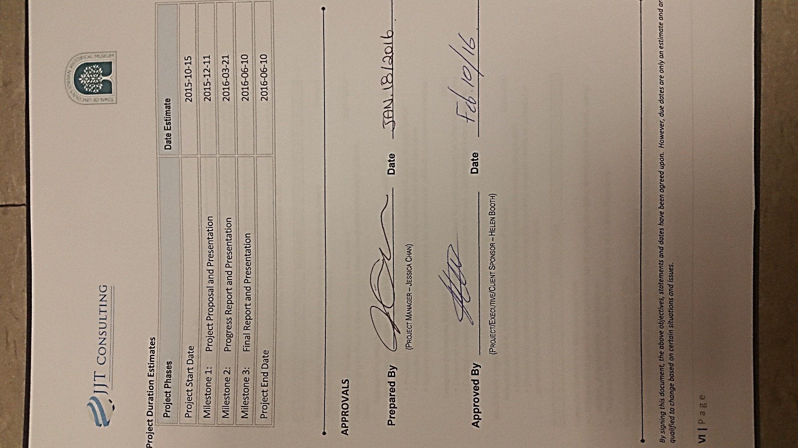

# Appendix 2

## Town of Lincoln’s Jordan Historical Museum Site Development Project



**Introduction**

The Town of Lincoln’s Jordan Historical Museum has been a fixture in the cultural landscape of Niagara since its beginnings in 1953 and is among some of the oldest museums in Canada. It proudly represents the story of the five communities of the Town of Lincoln, including one of the oldest settlements in Canada: that of the Pennsylvania German Mennonites who settled here in 1800.

The museum boasts two historic buildings.

* **The Fry House**: built in 1815, this wooden farm house is one of the last remaining structures of its type and features the life of the Fry family who built it.
* **The School House**: built of local limestone in 1859 and used up to 1948, the school house has been restored to how it would have looked in 1908.

The Jordan Historical Museum has its origins as a volunteer-based organization and while it became municipally owned and operated in 1995, it still stays deeply connected to the community through a vital and active Volunteer Association. The museum has reached out to the wider community through a broad range of high quality public and educational programming, featuring:

* **Pioneer Day:** coming into its 50th year, this festival is a tradition that highlights the activities, foods and crafts of early settlers.
* **Haunted Tour:** always sold out, this highly imaginative event brings the story of Jordan Village alive through tales of its past.
* **“Strict but Nice”:** this program is offered to schools in the School House as a field trip to compliment the Grade Three curriculum. It is an extremely detailed and historically accurate interactive program that is highly regarded by the educational community.

Other activities include a regular exhibit schedule, summer tours of the two historic buildings and children’s activities, a year-round lecture and workshop series, and many other special events and activities, both on- and off-site.

The museum is the custodian of an important Permanent Collection of over 10,000 artifacts. Highlights of the Collection include one of the largest assemblages of *fraktur* folk art, a Pennsylvania German Mennonite medium that is highly collectible and very valuable. The Collection also holds material culture of the settlers and later townspeople of Beamsville, Vineland, Campden, Tintern, Rockway and Jordan.

**Redevelopment**

After sixty-three years, understanding that the current conditions for the Museum’s Collections, exhibits, and programming space are woefully inadequate, the Jordan Historical Museum is moving into a new era and plans are afoot to redevelop the entire site.

The Museum is located in the Village of Jordan, the Town of Lincoln’s hub for tourism, arts and culture and related economic development. Based on the site plan shown below, it is poised to develop into a key driver for each of those elements, as well as exploding into its potential as a community resource and destination.

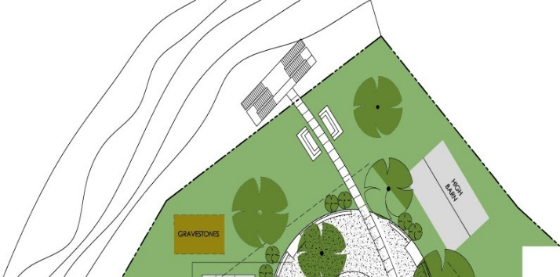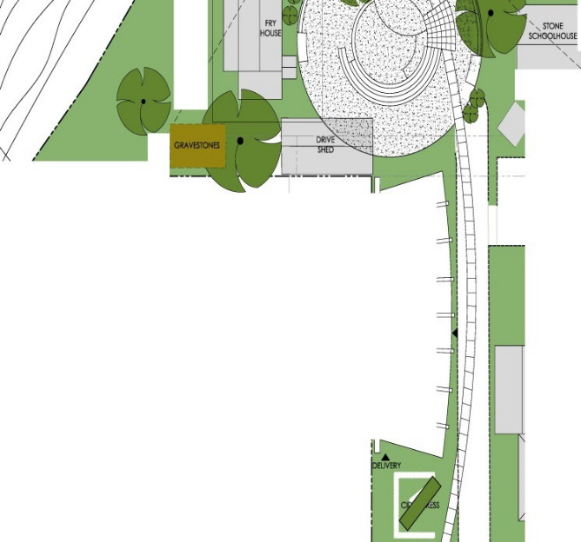

**What Does It Mean?**

The redevelopment of the Jordan Historical Museum closely ties in with the new and welcome direction from all levels of government toward celebrating Canada’s cultural assets and resources. That direction clearly recognizes the economic value of cultural resources and the social impact of such assets toward the development of healthy and thriving communities.

Further, the projected completion of the project is in 2017, which is the 150th anniversary of Canada’s Confederation. The opportunity to help celebrate such a milestone event in Canada’s history with such a long-awaited and meaningful project cannot be overlooked!

In the short term, job creation for the project will include technical and engineering personnel, construction crews, archaeologists, conservation specialists, and many other types of skilled craftspeople. It will also offer myriad volunteer opportunities for the moving and relocation of artifacts and other complimentary and associated projects.

In the long term, the redevelopment will be extremely beneficial. Potential effects are unlimited, but will include:

* Growth and development of the site coordinated with the renewed emphasis on cultural planning at the local, regional, provincial and national levels;
* Interest created by the authentically Canadian stamp of the architectural design of the site, which includes the new building itself as well as the overall concept which leads the visitor through the historical elements of the site to the natural heritage overlook of the Twenty Valley;
* Increased local community interest and value of the museum in general by the re- naming as “Lincoln’s Heritage Gateway”;
* Increased tourism traffic with associated economic spinoff that will impact the entire Town of Lincoln and extend out into the Niagara region;
* Vastly improved ability to protect, house, exhibit and provide access to the Permanent Collection of artifacts;
* The ability to open the current limitations on collecting due to lack of space, allowing the Collection to grow and to open the end-date from 1930 to the present;
* Accessible access to research materials and reference library;
* Much needed outdoor event space available to the entire community;
* Much needed indoor event/programming space for the museum and the community at large;
* Increased opportunities for community volunteer involvement through space and availability of artifacts and programs.

Recognizing the enormous potential of the museum’s redevelopment, the Town of Lincoln’s Council has enthusiastically endorsed the project and has approved the engagement of +VG Architects Group to provide consulting and project management services for the redevelopment of the Jordan Historical Museum Site.

The redevelopment of the Museum will be carried out in a phased approach.

* In 2016, this will involve a detailed design for the site and buildings prior to and in readiness for construction including provision for geotechnical surveys, archaeology, engineering and other preparatory work.
* In 2017, the work is expected to include the construction of the main facility, the amphitheater and landscaping/site detailing.

**The Bottom Line**

It is expected that the entire project will cost approximately $3 million.

We have a pledge from our Volunteer Association for a donation of $1 million, plus another recently announced donation of $10,000 toward a particular element of the project.

In 2016, the Town of Lincoln has approved $213, 750 for the detailed design work, including provision for geotechnical surveys, archaeology, engineering and other preparatory work.

The remainder of the funds will be sourced through grant applications from various sources including local foundations and corporations, as well as government funding.

# Appendix 3

## Public Media

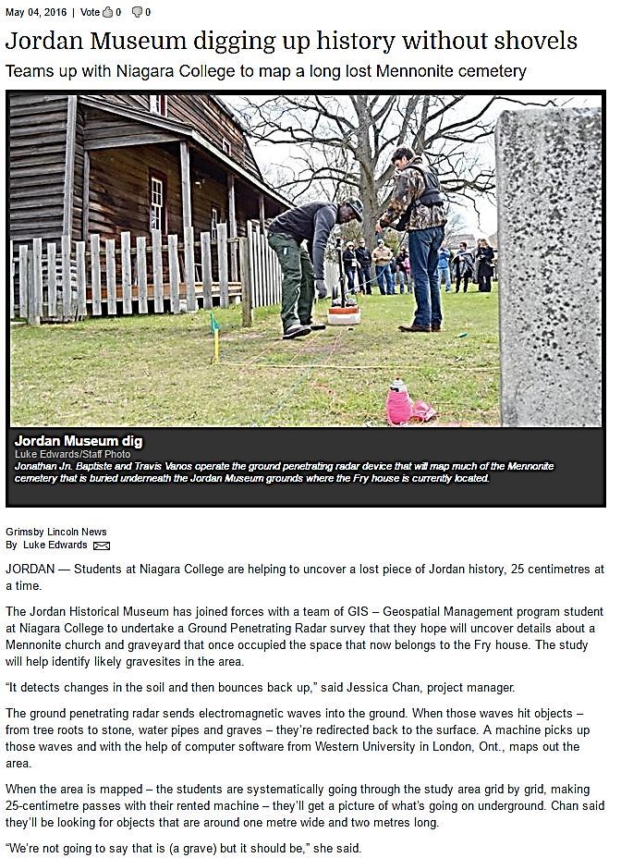

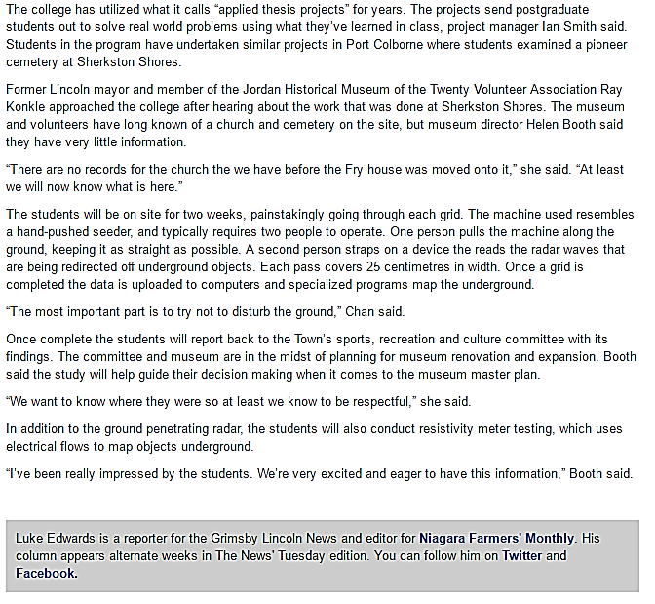

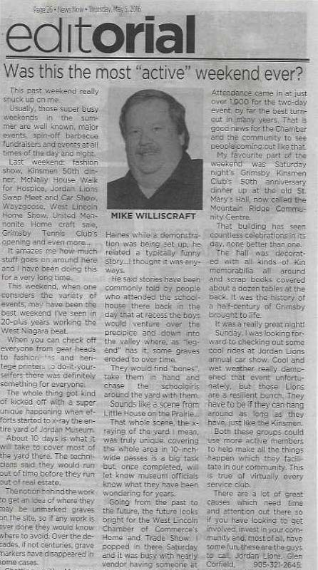

# Glossary

**Anomalies -** Something that is unusual or unexpected: something anomalous.

**ArcGIS -** Professional GIS software for creating maps, conducting spatial analysis and sharing intelligent visualizations for better decision making.

**Backsight -** a reading of the leveling rod in its unchanged position when the leveling instrument has been   
taken to a new position.

**Consultant Archaeologist -** means, as defined in Ontario regulation as an archaeologist who enters into an agreement with a client to carry out or supervise archaeological fieldwork on behalf of the client, produce reports for or on behalf of the client and provide technical advice to the client. In Ontario, these people also are required to hold a valid professional archaeological licence issued by the Ministry of Tourism, Culture and Sport

**Control Point** - Locations known to have high degree of accuracy. They are used to convert digitized coordinates from paper maps and georeferencing to standard map projection coordinates.

**Dielectric Constant (ϵr) -** a quantity measuring the ability of a substance to store electrical energy in an electric field.

**Earned Value Management -** Earned Value Management (EVM) helps project managers to measure project performance. It is a systematic project management process used to find variances in projects based on the comparison of worked performed and work planned. EVM is used on the cost and schedule control and can be very useful in project forecasting. The project baseline is an essential component of EVM and serves as a reference point for all EVM related activities. EVM provides quantitative data for project decision making.

**Electrical Resistance Meter -** Also called a **Resistivity Meter**. An instrument used to carry out resistiv­ity surveys that usually has a current transmitter and volt­age-measuring circuitry.

**Geographic Information Systems -** A geographic information system (GIS) lets us visualize, question, analyze, and interpret data to understand relationships, patterns, and trends.

**Georeference -** To georeference means to associate something with [location](http://en.mimi.hu/gis/location.html#maintitle)s in physical space. The term is commonly used in the [geographic information systems](http://en.mimi.hu/gis/geographic_information_systems.html#maintitle) field to describe the process of associating a physical [map](http://en.mimi.hu/gis/map.html#maintitle) or [raster](http://en.mimi.hu/gis/raster.html#maintitle) [image](http://en.mimi.hu/gis/image.html#maintitle) of a [map](http://en.mimi.hu/gis/map.html#maintitle) with spatial locations.

**GPR Antenna -** A component of the GPR system also called a transducer, transmits pulses of ultra-high frequency radio waves (microwave electromagnetic energy) down into the ground. The transmitted energy is reflected from various buried objects or distinct contacts between different earth materials. The antenna then receives the reflected waves and stores them in the digital control unit. The control unit registers the reflections against two-way travel time in nanoseconds and then amplifies the signals. The output signal voltage peaks are plotted on the ground penetrating radar profile as different color bands by the digital control unit.

**Ground Penetrating Radar** - Ground penetrating radar (GPR) is a non-destructive geophysical method that produces a continuous cross-sectional profile or record of subsurface features, without drilling, probing, or digging. The GPR cross-section shows the ground surface at the top of the profile, and the reflections of subsurface geologic units and objects to a certain depth at the bottom.

**GSSI’s RADAN 6.0 -** RADAN® is GSSI's state-of-the-art post-processing software.

**GSSI’s SIR-3000 System -** Geophysical Survey Systems Inc.’s SIR® 3000 is the industry’s number one choice for data accuracy and versatility.  The SIR 3000 incorporates advanced signal processing and display capability for ‘in-the-field’ 3D imaging. Unlike other data acquisition products on the market, the SIR 3000 is interchangeable with all GSSI antennas, making it an affordable and flexible option for multi-application users.

**Interment -** An act of placing a body in a grave or tomb.

**Megahertz (MHz) -** Abbreviation for **m***ega***h***ert***z**. One MHz represents one million cycles per second.

**Milliamp (mA) -** A unit of current equal to one thousandth (10-3) of an ampere.

**Mobile Probes -** The voltage and current probes on the bottom of the frame used to navigate the survey area.

**Nanoseconds -** One billionth of a second.

**Odometer-** An instrument for recording elapsed distance.

**Ohms (Ω) -** The ohm is the standard unit of electrical [resistance](http://searchcio-midmarket.techtarget.com/definition/resistance) in the International System of Units ([SI](http://whatis.techtarget.com/definition/International-System-of-Units-SI)).

**Proponent -** A person, agency, group or organization that carries out or proposes to carry out an undertaking or is the owner or person having charge, management or control of an undertaking.

**Radargram -** The radargram is a measure of the reflection amplitudes and the travel time that the reflections take. Deeper objects take a longer for time for these reflections to be recorded. By slicing many radargram profiles collected across the site, we can see reflections at various travel times, or depths within the ground.

**Remote Probes -** Also called **fixed probes**. The voltage and current probes placed in the ground approximately 30 times the distance away from the mobile probes.

**Topographic Survey -** determining the relative locations of points (places) on the earth's surface by measuring horizontal distances, differences in elevation and directions.

**Total Station -** The Total Station is a combination of [Electromagnetic Distance Measuring Instrument](http://theconstructor.org/surveying/electromagnetic-distance-measuring-instruments/6576/) and electronic theodolite. It is also integrated with microprocessor, electronic data collector and storage system. The instrument can be used to measure horizontal and vertical angles as well as sloping distance of object to the instrument.

**Twin-probe Configuration-** The twin-probe array consists of two mobile probes, usually mounted on a frame and a long cable leading to two fixed probes which are placed some distance away from the survey area. 